Supplementary Technical Report: Model Performance and Ablation Studies for Multi-step Exchange Rate Forecasting
This technical report serves as a supplementary document to the main article, providing comprehensive experimental results, visualizations, and ablation studies for the proposed multi-step forecasting model applied to four major currency pairs: USD/CNY, EUR/USD, USD/JPY, and AUD/USD. All supporting data, figures, and extended analyses referenced in the main text are included herein.
1. Model Performance Comparison Across Currency Pairs
This section presents detailed performance metrics (R², MAE, MSE, MAPE) for the proposed model (MyModel) and baseline models across 16 prediction steps for each currency pair. Results are summarized in Tables 1-4.
Table 1 Performance comparison on USD/CNY forecasting.
$$R^{2}$$ | MyModel | bi-GRU | GRU | bi-LSTM | LSTM | RNN | ANN | Transformer-LSTM | DARNN
step1 | 0.9649 | 0.9490 | 0.9033 | 0.9289 | 0.9333 | 0.9920 | 0.8851 | 0.4013 | 0.9771
step2 | 0.9352 | 0.9485 | 0.8943 | 0.9166 | 0.9379 | 0.9872 | 0.8850 | 0.4404 | 0.9560
step3 | 0.9674 | 0.9308 | 0.8893 | 0.9065 | 0.9211 | 0.9807 | 0.8747 | 0.4402 | 0.9257
step4 | 0.9811 | 0.9235 | 0.8818 | 0.9304 | 0.9228 | 0.9755 | 0.8681 | 0.4180 | 0.9137
step5 | 0.9692 | 0.9251 | 0.8747 | 0.9338 | 0.9103 | 0.9748 | 0.8709 | 0.3635 | 0.9091
step6 | 0.9656 | 0.9052 | 0.8705 | 0.9224 | 0.9089 | 0.9705 | 0.8606 | -0.2503 | 0.9028
step7 | 0.9643 | 0.8980 | 0.8618 | 0.9193 | 0.8898 | 0.9653 | 0.8647 | 0.4187 | 0.8966
step8 | 0.9612 | 0.8851 | 0.8589 | 0.8982 | 0.8969 | 0.9594 | 0.8510 | 0.1552 | 0.8909
step9 | 0.9571 | 0.8787 | 0.8507 | 0.9056 | 0.8720 | 0.9554 | 0.8493 | 0.2452 | 0.8858
step10 | 0.9521 | 0.8779 | 0.8434 | 0.8946 | 0.8781 | 0.9499 | 0.8344 | 0.2815 | 0.8807
step11 | 0.9471 | 0.8642 | 0.8353 | 0.8778 | 0.8560 | 0.9421 | 0.8359 | 0.3694 | 0.8758
step12 | 0.9421 | 0.8626 | 0.8293 | 0.8827 | 0.8425 | 0.9358 | 0.8268 | 0.2917 | 0.8708
step13 | 0.9369 | 0.8394 | 0.8213 | 0.8801 | 0.8473 | 0.9328 | 0.8218 | 0.3335 | 0.8655
step14 | 0.9310 | 0.8240 | 0.8097 | 0.8688 | 0.8407 | 0.9264 | 0.8147 | -0.0098 | 0.8596
step15 | 0.9249 | 0.8239 | 0.8038 | 0.8582 | 0.8261 | 0.9210 | 0.8044 | 0.2254 | 0.8535
step16 | 0.9184 | 0.8233 | 0.7957 | 0.8410 | 0.8294 | 0.9129 | 0.7989 | 0.2993 | 0.8470
total | 0.9512 | 0.8849 | 0.8515 | 0.8978 | 0.8821 | 0.9551 | 0.8467 | 0.2765 | 0.8944
$$MAE$$ | MyModel | bi-GRU | GRU | bi-LSTM | LSTM | RNN | ANN | Transformer-LSTM | DARNN
step1 | 0.0429 | 0.0460 | 0.0659 | 0.0548 | 0.0519 | 0.0174 | 0.0813 | 0.1743 | 0.0359
step2 | 0.0642 | 0.0464 | 0.0687 | 0.0617 | 0.0505 | 0.0221 | 0.0811 | 0.1700 | 0.0504
step3 | 0.0420 | 0.0535 | 0.0701 | 0.0638 | 0.0567 | 0.0278 | 0.0830 | 0.1695 | 0.0659
step4 | 0.0278 | 0.0562 | 0.0726 | 0.0535 | 0.0557 | 0.0313 | 0.0852 | 0.1708 | 0.0702
step5 | 0.0378 | 0.0557 | 0.0745 | 0.0506 | 0.0601 | 0.0313 | 0.0838 | 0.1770 | 0.0708
step6 | 0.0390 | 0.0628 | 0.0757 | 0.0563 | 0.0604 | 0.0337 | 0.0868 | 0.2510 | 0.0723
step7 | 0.0384 | 0.0652 | 0.0783 | 0.0588 | 0.0665 | 0.0366 | 0.0841 | 0.1712 | 0.0737
step8 | 0.0391 | 0.0698 | 0.0788 | 0.0670 | 0.0643 | 0.0396 | 0.0877 | 0.2028 | 0.0749
step9 | 0.0409 | 0.0715 | 0.0810 | 0.0614 | 0.0720 | 0.0415 | 0.0884 | 0.1918 | 0.0759
step10 | 0.0431 | 0.0719 | 0.0830 | 0.0669 | 0.0703 | 0.0442 | 0.0929 | 0.1872 | 0.0768
step11 | 0.0455 | 0.0760 | 0.0852 | 0.0720 | 0.0768 | 0.0480 | 0.0910 | 0.1760 | 0.0777
step12 | 0.0478 | 0.0763 | 0.0868 | 0.0688 | 0.0803 | 0.0510 | 0.0941 | 0.1851 | 0.0786
step13 | 0.0501 | 0.0831 | 0.0888 | 0.0697 | 0.0787 | 0.0518 | 0.0943 | 0.1832 | 0.0797
step14 | 0.0526 | 0.0875 | 0.0917 | 0.0734 | 0.0806 | 0.0544 | 0.0962 | 0.2214 | 0.0810
step15 | 0.0550 | 0.0877 | 0.0932 | 0.0758 | 0.0846 | 0.0564 | 0.0990 | 0.1929 | 0.0825
step16 | 0.0574 | 0.0872 | 0.0952 | 0.0806 | 0.0837 | 0.0595 | 0.0997 | 0.1830 | 0.0840
total | 0.0452 | 0.0685 | 0.0806 | 0.0647 | 0.0683 | 0.0404 | 0.0893 | 0.1879 | 0.0719
$$MSE$$ | MyModel | bi-GRU | GRU | bi-LSTM | LSTM | RNN | ANN | Transformer-LSTM | DARNN
step1 | 0.0026 | 0.0038 | 0.0072 | 0.0053 | 0.0050 | 0.0006 | 0.0086 | 0.0448 | 0.0017
step2 | 0.0048 | 0.0038 | 0.0079 | 0.0062 | 0.0046 | 0.0010 | 0.0086 | 0.0419 | 0.0033
step3 | 0.0024 | 0.0052 | 0.0083 | 0.0070 | 0.0059 | 0.0014 | 0.0094 | 0.0419 | 0.0056
step4 | 0.0014 | 0.0057 | 0.0088 | 0.0052 | 0.0058 | 0.0018 | 0.0099 | 0.0436 | 0.0065
step5 | 0.0023 | 0.0056 | 0.0094 | 0.0050 | 0.0067 | 0.0019 | 0.0097 | 0.0477 | 0.0068
step6 | 0.0026 | 0.0071 | 0.0097 | 0.0058 | 0.0068 | 0.0022 | 0.0104 | 0.0937 | 0.0073
step7 | 0.0027 | 0.0076 | 0.0104 | 0.0060 | 0.0083 | 0.0026 | 0.0101 | 0.0436 | 0.0077
step8 | 0.0029 | 0.0086 | 0.0106 | 0.0076 | 0.0077 | 0.0030 | 0.0112 | 0.0633 | 0.0082
step9 | 0.0032 | 0.0091 | 0.0112 | 0.0071 | 0.0096 | 0.0033 | 0.0113 | 0.0566 | 0.0086
step10 | 0.0036 | 0.0092 | 0.0117 | 0.0079 | 0.0091 | 0.0038 | 0.0124 | 0.0539 | 0.0089
step11 | 0.0040 | 0.0102 | 0.0124 | 0.0092 | 0.0108 | 0.0043 | 0.0123 | 0.0473 | 0.0093
step12 | 0.0043 | 0.0103 | 0.0128 | 0.0088 | 0.0118 | 0.0048 | 0.0130 | 0.0532 | 0.0097
step13 | 0.0047 | 0.0121 | 0.0134 | 0.0090 | 0.0115 | 0.0050 | 0.0134 | 0.0500 | 0.0101
step14 | 0.0052 | 0.0132 | 0.0143 | 0.0099 | 0.0120 | 0.0055 | 0.0139 | 0.0758 | 0.0105
step15 | 0.0056 | 0.0132 | 0.0147 | 0.0106 | 0.0131 | 0.0059 | 0.0147 | 0.0582 | 0.0110
step16 | 0.0061 | 0.0133 | 0.0154 | 0.0120 | 0.0128 | 0.0065 | 0.0151 | 0.0527 | 0.0115
total | 0.0037 | 0.0086 | 0.0111 | 0.0077 | 0.0088 | 0.0034 | 0.0115 | 0.0542 | 0.0079
$$MAPE$$ | MyModel | bi-GRU | GRU | bi-LSTM | LSTM | RNN | ANN | Transformer-LSTM | DARNN
step1 | 0.0062 | 0.0067 | 0.0097 | 0.0080 | 0.0076 | 0.0026 | 0.0120 | 0.0261 | 0.0052
step2 | 0.0096 | 0.0068 | 0.0102 | 0.0090 | 0.0074 | 0.0032 | 0.0119 | 0.0251 | 0.0074
step3 | 0.0062 | 0.0078 | 0.0104 | 0.0093 | 0.0083 | 0.0041 | 0.0122 | 0.0251 | 0.0096
step4 | 0.0041 | 0.0082 | 0.0107 | 0.0078 | 0.0082 | 0.0046 | 0.0125 | 0.0255 | 0.0102
step5 | 0.0056 | 0.0082 | 0.0110 | 0.0074 | 0.0088 | 0.0046 | 0.0123 | 0.0265 | 0.0103
step6 | 0.0058 | 0.0092 | 0.0112 | 0.0083 | 0.0089 | 0.0050 | 0.0128 | 0.0380 | 0.0105
step7 | 0.0057 | 0.0096 | 0.0115 | 0.0086 | 0.0098 | 0.0054 | 0.0124 | 0.0255 | 0.0108
step8 | 0.0058 | 0.0102 | 0.0116 | 0.0098 | 0.0095 | 0.0058 | 0.0129 | 0.0306 | 0.0109
step9 | 0.0060 | 0.0105 | 0.0119 | 0.0090 | 0.0106 | 0.0061 | 0.0130 | 0.0289 | 0.0111
step10 | 0.0064 | 0.0105 | 0.0122 | 0.0098 | 0.0103 | 0.0065 | 0.0136 | 0.0282 | 0.0112
step11 | 0.0067 | 0.0111 | 0.0126 | 0.0106 | 0.0113 | 0.0071 | 0.0134 | 0.0263 | 0.0113
step12 | 0.0070 | 0.0112 | 0.0128 | 0.0101 | 0.0118 | 0.0075 | 0.0138 | 0.0278 | 0.0115
step13 | 0.0074 | 0.0122 | 0.0131 | 0.0102 | 0.0116 | 0.0076 | 0.0139 | 0.0269 | 0.0116
step14 | 0.0078 | 0.0128 | 0.0135 | 0.0108 | 0.0119 | 0.0080 | 0.0141 | 0.0335 | 0.0118
step15 | 0.0081 | 0.0128 | 0.0137 | 0.0112 | 0.0124 | 0.0083 | 0.0145 | 0.0290 | 0.0120
step16 | 0.0085 | 0.0128 | 0.0140 | 0.0119 | 0.0123 | 0.0087 | 0.0146 | 0.0274 | 0.0122
total | 0.0067 | 0.0100 | 0.0119 | 0.0095 | 0.0100 | 0.0059 | 0.0131 | 0.0281 | 0.0105

Table 2 Performance comparison on EUR/USD forecasting.
$$R^{2}$$ | MyModel | bi-GRU | GRU | bi-LSTM | LSTM | RNN | ANN | Transformer-LSTM | DARNN
step1 | 0.9807 | 0.8253 | 0.9274 | 0.9558 | 0.9357 | 0.9859 | 0.9353 | 0.7201 | 0.9787
step2 | 0.9774 | 0.8555 | 0.9113 | 0.9373 | 0.9239 | 0.9741 | 0.9147 | 0.6671 | 0.9600
step3 | 0.9692 | 0.8576 | 0.9003 | 0.9107 | 0.9033 | 0.9642 | 0.8957 | 0.6509 | 0.9554
step4 | 0.9608 | 0.8179 | 0.8997 | 0.9243 | 0.9038 | 0.9591 | 0.8920 | 0.7138 | 0.9490
step5 | 0.9513 | 0.8535 | 0.8743 | 0.9116 | 0.8947 | 0.9505 | 0.8607 | 0.6263 | 0.9414
step6 | 0.9419 | 0.8345 | 0.8677 | 0.8778 | 0.8873 | 0.9434 | 0.8804 | 0.6368 | 0.9328
step7 | 0.9337 | 0.8598 | 0.8708 | 0.8831 | 0.8709 | 0.9327 | 0.8582 | 0.7029 | 0.9252
step8 | 0.9262 | 0.8204 | 0.8571 | 0.8593 | 0.8700 | 0.9284 | 0.8213 | 0.6090 | 0.9184
step9 | 0.9185 | 0.8373 | 0.8506 | 0.8993 | 0.8473 | 0.9161 | 0.8361 | 0.6536 | 0.9112
step10 | 0.9111 | 0.8163 | 0.8361 | 0.8708 | 0.8379 | 0.9098 | 0.8486 | 0.5999 | 0.9041
step11 | 0.9043 | 0.7923 | 0.8243 | 0.8773 | 0.8389 | 0.9055 | 0.7702 | 0.5841 | 0.8978
step12 | 0.8976 | 0.8081 | 0.8300 | 0.8122 | 0.8252 | 0.8999 | 0.8026 | 0.5473 | 0.8916
step13 | 0.8910 | 0.8028 | 0.8206 | 0.8717 | 0.8167 | 0.8904 | 0.7691 | 0.5847 | 0.8855
step14 | 0.8844 | 0.8252 | 0.7918 | 0.8372 | 0.8135 | 0.8860 | 0.7706 | 0.4557 | 0.8797
step15 | 0.8771 | 0.7803 | 0.7800 | 0.8345 | 0.8035 | 0.8731 | 0.7295 | 0.6000 | 0.8729
step16 | 0.8705 | 0.7922 | 0.7826 | 0.8402 | 0.7747 | 0.8702 | 0.7288 | 0.5608 | 0.8672
total | 0.9247 | 0.8237 | 0.8515 | 0.8814 | 0.8592 | 0.9243 | 0.8321 | 0.6196 | 0.9169
$$MAE$$ | MyModel | bi-GRU | GRU | bi-LSTM | LSTM | RNN | ANN | Transformer-LSTM | DARNN
step1 | 0.0057 | 0.0217 | 0.0126 | 0.0090 | 0.0112 | 0.0050 | 0.0121 | 0.0225 | 0.0065
step2 | 0.0063 | 0.0190 | 0.0135 | 0.0109 | 0.0121 | 0.0067 | 0.0136 | 0.0249 | 0.0085
step3 | 0.0073 | 0.0183 | 0.0144 | 0.0132 | 0.0136 | 0.0079 | 0.0150 | 0.0255 | 0.0089
step4 | 0.0082 | 0.0207 | 0.0141 | 0.0117 | 0.0135 | 0.0084 | 0.0150 | 0.0226 | 0.0095
step5 | 0.0091 | 0.0179 | 0.0157 | 0.0127 | 0.0142 | 0.0093 | 0.0172 | 0.0266 | 0.0102
step6 | 0.0100 | 0.0188 | 0.0162 | 0.0152 | 0.0145 | 0.0098 | 0.0155 | 0.0260 | 0.0109
step7 | 0.0107 | 0.0168 | 0.0158 | 0.0147 | 0.0155 | 0.0108 | 0.0169 | 0.0230 | 0.0115
step8 | 0.0112 | 0.0193 | 0.0166 | 0.0164 | 0.0155 | 0.0110 | 0.0192 | 0.0270 | 0.0121
step9 | 0.0118 | 0.0179 | 0.0171 | 0.0134 | 0.0170 | 0.0120 | 0.0181 | 0.0250 | 0.0126
step10 | 0.0124 | 0.0192 | 0.0178 | 0.0154 | 0.0174 | 0.0125 | 0.0171 | 0.0272 | 0.0130
step11 | 0.0130 | 0.0205 | 0.0186 | 0.0149 | 0.0174 | 0.0128 | 0.0218 | 0.0279 | 0.0134
step12 | 0.0135 | 0.0194 | 0.0182 | 0.0189 | 0.0181 | 0.0133 | 0.0198 | 0.0294 | 0.0139
step13 | 0.0140 | 0.0197 | 0.0187 | 0.0151 | 0.0187 | 0.0140 | 0.0216 | 0.0278 | 0.0143
step14 | 0.0144 | 0.0183 | 0.0203 | 0.0173 | 0.0190 | 0.0143 | 0.0215 | 0.0327 | 0.0146
step15 | 0.0150 | 0.0208 | 0.0209 | 0.0174 | 0.0196 | 0.0152 | 0.0235 | 0.0271 | 0.0151
step16 | 0.0155 | 0.0200 | 0.0207 | 0.0171 | 0.0209 | 0.0155 | 0.0233 | 0.0286 | 0.0155
total | 0.0111 | 0.0193 | 0.0170 | 0.0146 | 0.0161 | 0.0112 | 0.0182 | 0.0265 | 0.0119
$$MSE$$ | MyModel | bi-GRU | GRU | bi-LSTM | LSTM | RNN | ANN | Transformer-LSTM | DARNN
step1 | 0.0001 | 0.0005 | 0.0002 | 0.0001 | 0.0002 | 0.0000 | 0.0002 | 0.0008 | 0.0001
step2 | 0.0001 | 0.0004 | 0.0003 | 0.0002 | 0.0002 | 0.0001 | 0.0002 | 0.0010 | 0.0001
step3 | 0.0001 | 0.0004 | 0.0003 | 0.0003 | 0.0003 | 0.0001 | 0.0003 | 0.0010 | 0.0001
step4 | 0.0001 | 0.0005 | 0.0003 | 0.0002 | 0.0003 | 0.0001 | 0.0003 | 0.0008 | 0.0001
step5 | 0.0001 | 0.0004 | 0.0004 | 0.0003 | 0.0003 | 0.0001 | 0.0004 | 0.0011 | 0.0002
step6 | 0.0002 | 0.0005 | 0.0004 | 0.0004 | 0.0003 | 0.0002 | 0.0003 | 0.0011 | 0.0002
step7 | 0.0002 | 0.0004 | 0.0004 | 0.0003 | 0.0004 | 0.0002 | 0.0004 | 0.0009 | 0.0002
step8 | 0.0002 | 0.0005 | 0.0004 | 0.0004 | 0.0004 | 0.0002 | 0.0005 | 0.0011 | 0.0002
step9 | 0.0002 | 0.0005 | 0.0004 | 0.0003 | 0.0004 | 0.0002 | 0.0005 | 0.0010 | 0.0003
step10 | 0.0003 | 0.0005 | 0.0005 | 0.0004 | 0.0005 | 0.0003 | 0.0004 | 0.0012 | 0.0003
step11 | 0.0003 | 0.0006 | 0.0005 | 0.0004 | 0.0005 | 0.0003 | 0.0007 | 0.0012 | 0.0003
step12 | 0.0003 | 0.0006 | 0.0005 | 0.0005 | 0.0005 | 0.0003 | 0.0006 | 0.0013 | 0.0003
step13 | 0.0003 | 0.0006 | 0.0005 | 0.0004 | 0.0005 | 0.0003 | 0.0007 | 0.0012 | 0.0003
step14 | 0.0003 | 0.0005 | 0.0006 | 0.0005 | 0.0005 | 0.0003 | 0.0007 | 0.0016 | 0.0003
step15 | 0.0004 | 0.0006 | 0.0006 | 0.0005 | 0.0006 | 0.0004 | 0.0008 | 0.0012 | 0.0004
step16 | 0.0004 | 0.0006 | 0.0006 | 0.0005 | 0.0007 | 0.0004 | 0.0008 | 0.0013 | 0.0004
total | 0.0002 | 0.0005 | 0.0004 | 0.0003 | 0.0004 | 0.0002 | 0.0005 | 0.0011 | 0.0002
$$MAPE$$ | MyModel | bi-GRU | GRU | bi-LSTM | LSTM | RNN | ANN | Transformer-LSTM | DARNN
step1 | 0.0051 | 0.0194 | 0.0113 | 0.0081 | 0.0101 | 0.0044 | 0.0108 | 0.0201 | 0.0058
step2 | 0.0056 | 0.0171 | 0.0121 | 0.0099 | 0.0109 | 0.0060 | 0.0122 | 0.0223 | 0.0077
step3 | 0.0065 | 0.0164 | 0.0129 | 0.0120 | 0.0123 | 0.0071 | 0.0134 | 0.0229 | 0.0081
step4 | 0.0074 | 0.0185 | 0.0127 | 0.0106 | 0.0122 | 0.0075 | 0.0134 | 0.0203 | 0.0086
step5 | 0.0082 | 0.0161 | 0.0142 | 0.0115 | 0.0128 | 0.0083 | 0.0154 | 0.0238 | 0.0092
step6 | 0.0090 | 0.0169 | 0.0146 | 0.0138 | 0.0131 | 0.0088 | 0.0139 | 0.0233 | 0.0098
step7 | 0.0096 | 0.0151 | 0.0142 | 0.0133 | 0.0140 | 0.0097 | 0.0151 | 0.0206 | 0.0104
step8 | 0.0101 | 0.0174 | 0.0150 | 0.0149 | 0.0140 | 0.0099 | 0.0172 | 0.0242 | 0.0109
step9 | 0.0106 | 0.0161 | 0.0154 | 0.0120 | 0.0153 | 0.0108 | 0.0162 | 0.0224 | 0.0113
step10 | 0.0112 | 0.0173 | 0.0161 | 0.0139 | 0.0157 | 0.0112 | 0.0153 | 0.0244 | 0.0117
step11 | 0.0117 | 0.0184 | 0.0168 | 0.0134 | 0.0157 | 0.0115 | 0.0196 | 0.0251 | 0.0121
step12 | 0.0121 | 0.0174 | 0.0164 | 0.0171 | 0.0163 | 0.0120 | 0.0178 | 0.0264 | 0.0125
step13 | 0.0126 | 0.0177 | 0.0169 | 0.0136 | 0.0168 | 0.0126 | 0.0194 | 0.0249 | 0.0128
step14 | 0.0130 | 0.0164 | 0.0183 | 0.0157 | 0.0171 | 0.0129 | 0.0192 | 0.0294 | 0.0132
step15 | 0.0134 | 0.0187 | 0.0188 | 0.0158 | 0.0177 | 0.0137 | 0.0211 | 0.0243 | 0.0136
step16 | 0.0139 | 0.0181 | 0.0187 | 0.0154 | 0.0188 | 0.0139 | 0.0209 | 0.0257 | 0.0139
total | 0.0100 | 0.0173 | 0.0153 | 0.0132 | 0.0146 | 0.0100 | 0.0163 | 0.0238 | 0.0107

Table 3 Performance comparison on USD/JPY forecasting.
$$R^{2}$$ | MyModel | bi-GRU | GRU | bi-LSTM | LSTM | RNN | ANN | Transformer-LSTM | DARNN
step1 | 0.9940 | 0.9944 | 0.9786 | 0.9804 | 0.9540 | 0.9938 | 0.9913 | 0.9462 | 0.9953
step2 | 0.9943 | 0.9930 | 0.9694 | 0.9764 | 0.9694 | 0.9906 | 0.9890 | 0.9435 | 0.9845
step3 | 0.9938 | 0.9906 | 0.9677 | 0.9746 | 0.9535 | 0.9901 | 0.9868 | 0.9439 | 0.9851
step4 | 0.9919 | 0.9890 | 0.9594 | 0.9691 | 0.9628 | 0.9879 | 0.9843 | 0.9510 | 0.9838
step5 | 0.9901 | 0.9878 | 0.9547 | 0.9631 | 0.9541 | 0.9867 | 0.9817 | 0.9434 | 0.9828
step6 | 0.9882 | 0.9841 | 0.9565 | 0.9598 | 0.9620 | 0.9835 | 0.9783 | 0.9378 | 0.9816
step7 | 0.9864 | 0.9831 | 0.9499 | 0.9627 | 0.9420 | 0.9812 | 0.9766 | 0.9300 | 0.9803
step8 | 0.9845 | 0.9808 | 0.9566 | 0.9583 | 0.9457 | 0.9798 | 0.9732 | 0.9191 | 0.9787
step9 | 0.9826 | 0.9768 | 0.9606 | 0.9608 | 0.9395 | 0.9785 | 0.9696 | 0.9283 | 0.9770
step10 | 0.9807 | 0.9777 | 0.9485 | 0.9582 | 0.9409 | 0.9746 | 0.9686 | 0.9287 | 0.9752
step11 | 0.9787 | 0.9739 | 0.9422 | 0.9559 | 0.9370 | 0.9742 | 0.9658 | 0.9290 | 0.9733
step12 | 0.9769 | 0.9706 | 0.9512 | 0.9439 | 0.9309 | 0.9716 | 0.9631 | 0.9139 | 0.9715
step13 | 0.9750 | 0.9685 | 0.9470 | 0.9476 | 0.9363 | 0.9690 | 0.9595 | 0.9209 | 0.9695
step14 | 0.9731 | 0.9679 | 0.9327 | 0.9472 | 0.9312 | 0.9658 | 0.9570 | 0.9046 | 0.9676
step15 | 0.9709 | 0.9664 | 0.9301 | 0.9413 | 0.9232 | 0.9630 | 0.9546 | 0.9066 | 0.9654
step16 | 0.9688 | 0.9622 | 0.9361 | 0.9415 | 0.9345 | 0.9599 | 0.9510 | 0.9007 | 0.9634
total | 0.9831 | 0.9792 | 0.9526 | 0.9588 | 0.9448 | 0.9781 | 0.9719 | 0.9280 | 0.9772
$$MAE$$ | MyModel | bi-GRU | GRU | bi-LSTM | LSTM | RNN | ANN | Transformer-LSTM | DARNN
step1 | 0.9064 | 0.8178 | 1.4642 | 1.4747 | 2.1058 | 0.9784 | 0.9052 | 2.4163 | 0.8034
step2 | 0.7569 | 0.8966 | 1.7238 | 1.5961 | 1.7477 | 1.1709 | 1.0212 | 2.4783 | 1.5056
step3 | 0.8059 | 1.0334 | 1.7882 | 1.6432 | 2.1521 | 1.1281 | 1.1403 | 2.4320 | 1.3182
step4 | 0.9634 | 1.1118 | 2.0133 | 1.8401 | 1.9290 | 1.2439 | 1.2701 | 2.3376 | 1.3058
step5 | 1.0681 | 1.1670 | 2.1151 | 1.9724 | 2.1481 | 1.2662 | 1.3632 | 2.4909 | 1.3549
step6 | 1.1528 | 1.3262 | 2.1196 | 2.0580 | 2.0006 | 1.4249 | 1.4909 | 2.5962 | 1.4109
step7 | 1.2347 | 1.3660 | 2.2433 | 1.9926 | 2.4370 | 1.5274 | 1.5603 | 2.7541 | 1.4734
step8 | 1.3133 | 1.4731 | 2.0987 | 2.0730 | 2.3235 | 1.5721 | 1.6678 | 2.9102 | 1.5408
step9 | 1.3841 | 1.6129 | 2.0252 | 2.0628 | 2.5000 | 1.5880 | 1.7783 | 2.7798 | 1.6059
step10 | 1.4650 | 1.5906 | 2.2997 | 2.1186 | 2.5103 | 1.7393 | 1.8228 | 2.7897 | 1.6763
step11 | 1.5381 | 1.7217 | 2.4130 | 2.1906 | 2.5851 | 1.7437 | 1.9109 | 2.7508 | 1.7471
step12 | 1.6069 | 1.8237 | 2.2575 | 2.4353 | 2.7355 | 1.8178 | 1.9891 | 3.0247 | 1.8134
step13 | 1.6884 | 1.9005 | 2.3631 | 2.3528 | 2.6104 | 1.9104 | 2.0869 | 2.9526 | 1.8819
step14 | 1.7653 | 1.9285 | 2.6914 | 2.3811 | 2.6917 | 1.9998 | 2.1504 | 3.2270 | 1.9549
step15 | 1.8395 | 1.9757 | 2.7009 | 2.4912 | 2.8853 | 2.0752 | 2.2124 | 3.2102 | 2.0207
step16 | 1.9055 | 2.0719 | 2.6006 | 2.5040 | 2.6373 | 2.1708 | 2.2959 | 3.3278 | 2.0814
total | 1.3371 | 1.4886 | 2.1823 | 2.0742 | 2.3750 | 1.5848 | 1.6666 | 2.7799 | 1.5934
$$MSE$$ | MyModel | bi-GRU | GRU | bi-LSTM | LSTM | RNN | ANN | Transformer-LSTM | DARNN
step1 | 1.2367 | 1.1614 | 4.4155 | 4.0427 | 9.4881 | 1.2743 | 1.7849 | 11.1011 | 0.9611
step2 | 1.1815 | 1.4481 | 6.3394 | 4.8807 | 6.3351 | 1.9456 | 2.2776 | 11.6828 | 3.2110
step3 | 1.2877 | 1.9411 | 6.7110 | 5.2689 | 9.6514 | 2.0588 | 2.7395 | 11.6330 | 3.0990
step4 | 1.6946 | 2.2901 | 8.4565 | 6.4221 | 7.7339 | 2.5241 | 3.2625 | 10.2014 | 3.3733
step5 | 2.0742 | 2.5490 | 9.4548 | 7.6954 | 9.5728 | 2.7710 | 3.8235 | 11.8059 | 3.5961
step6 | 2.4762 | 3.3189 | 9.1003 | 8.4146 | 7.9490 | 3.4602 | 4.5436 | 13.0238 | 3.8526
step7 | 2.8481 | 3.5513 | 10.5226 | 7.8227 | 12.1828 | 3.9546 | 4.9177 | 14.6978 | 4.1340
step8 | 3.2581 | 4.0433 | 9.1430 | 8.7771 | 11.4385 | 4.2500 | 5.6481 | 17.0224 | 4.4829
step9 | 3.6643 | 4.8994 | 8.3279 | 8.2769 | 12.7685 | 4.5303 | 6.4159 | 15.1438 | 4.8540
step10 | 4.0944 | 4.7192 | 10.9091 | 8.8501 | 12.5252 | 5.3702 | 6.6567 | 15.0949 | 5.2619
step11 | 4.5215 | 5.5459 | 12.2742 | 9.3786 | 13.3932 | 5.4769 | 7.2668 | 15.0946 | 5.6768
step12 | 4.9185 | 6.2579 | 10.3966 | 11.9641 | 14.7269 | 6.0503 | 7.8720 | 18.3467 | 6.0840
step13 | 5.3366 | 6.7310 | 11.3383 | 11.1963 | 13.6193 | 6.6296 | 8.6534 | 16.9135 | 6.5138
step14 | 5.7715 | 6.8845 | 14.4375 | 11.3338 | 14.7494 | 7.3268 | 9.2143 | 20.4753 | 6.9544
step15 | 6.2656 | 7.2254 | 15.0365 | 12.6334 | 16.5328 | 7.9605 | 9.7798 | 20.0970 | 7.4373
step16 | 6.7414 | 8.1555 | 13.8050 | 12.6378 | 14.1436 | 8.6577 | 10.5704 | 21.4327 | 7.9087
total | 3.5857 | 4.4201 | 10.0418 | 8.7247 | 11.6757 | 4.6401 | 5.9642 | 15.2354 | 4.8376
$$MAPE$$ | MyModel | bi-GRU | GRU | bi-LSTM | LSTM | RNN | ANN | Transformer-LSTM | DARNN
step1 | 0.0077 | 0.0067 | 0.0116 | 0.0120 | 0.0165 | 0.0083 | 0.0072 | 0.0193 | 0.0069
step2 | 0.0061 | 0.0073 | 0.0135 | 0.0128 | 0.0138 | 0.0098 | 0.0081 | 0.0197 | 0.0124
step3 | 0.0067 | 0.0085 | 0.0141 | 0.0131 | 0.0169 | 0.0093 | 0.0092 | 0.0193 | 0.0106
step4 | 0.0080 | 0.0091 | 0.0158 | 0.0147 | 0.0152 | 0.0103 | 0.0102 | 0.0187 | 0.0103
step5 | 0.0088 | 0.0096 | 0.0166 | 0.0157 | 0.0169 | 0.0104 | 0.0109 | 0.0198 | 0.0108
step6 | 0.0095 | 0.0108 | 0.0168 | 0.0163 | 0.0158 | 0.0117 | 0.0119 | 0.0206 | 0.0112
step7 | 0.0101 | 0.0111 | 0.0176 | 0.0158 | 0.0191 | 0.0125 | 0.0125 | 0.0218 | 0.0118
step8 | 0.0108 | 0.0120 | 0.0165 | 0.0163 | 0.0182 | 0.0129 | 0.0133 | 0.0231 | 0.0123
step9 | 0.0113 | 0.0130 | 0.0160 | 0.0164 | 0.0196 | 0.0129 | 0.0142 | 0.0220 | 0.0129
step10 | 0.0119 | 0.0129 | 0.0181 | 0.0168 | 0.0198 | 0.0141 | 0.0145 | 0.0221 | 0.0135
step11 | 0.0125 | 0.0139 | 0.0189 | 0.0174 | 0.0203 | 0.0141 | 0.0152 | 0.0217 | 0.0140
step12 | 0.0131 | 0.0146 | 0.0178 | 0.0192 | 0.0215 | 0.0146 | 0.0158 | 0.0239 | 0.0145
step13 | 0.0137 | 0.0152 | 0.0186 | 0.0186 | 0.0205 | 0.0153 | 0.0165 | 0.0234 | 0.0151
step14 | 0.0143 | 0.0155 | 0.0212 | 0.0188 | 0.0211 | 0.0160 | 0.0170 | 0.0254 | 0.0156
step15 | 0.0149 | 0.0159 | 0.0211 | 0.0196 | 0.0226 | 0.0166 | 0.0175 | 0.0253 | 0.0162
step16 | 0.0154 | 0.0165 | 0.0204 | 0.0198 | 0.0207 | 0.0174 | 0.0181 | 0.0262 | 0.0166
total | 0.0109 | 0.0120 | 0.0172 | 0.0165 | 0.0187 | 0.0129 | 0.0133 | 0.0220 | 0.0128

Table 4 Performance comparison on AUD/USD forecasting.
$$R^{2}$$ | MyModel | bi-GRU | GRU | bi-LSTM | LSTM | RNN | ANN | Transformer-LSTM | DARNN
step1 | 0.8397 | 0.9744 | 0.9701 | 0.9798 | 0.9646 | 0.9619 | 0.8898 | 0.8538 | 0.8392
step2 | 0.9645 | 0.9640 | 0.9548 | 0.9705 | 0.9476 | 0.9603 | 0.8898 | 0.8572 | 0.9767
step3 | 0.9605 | 0.9532 | 0.9474 | 0.9573 | 0.9372 | 0.9519 | 0.8898 | 0.8539 | 0.9586
step4 | 0.9505 | 0.9453 | 0.9359 | 0.9473 | 0.9297 | 0.9401 | 0.8898 | 0.8472 | 0.9255
step5 | 0.9400 | 0.9339 | 0.9215 | 0.9393 | 0.9249 | 0.9304 | 0.8898 | 0.8487 | 0.8988
step6 | 0.9300 | 0.9251 | 0.9167 | 0.9249 | 0.9069 | 0.9061 | 0.8898 | 0.8399 | 0.8815
step7 | 0.9206 | 0.9161 | 0.9035 | 0.9217 | 0.8959 | 0.9095 | 0.8898 | 0.8166 | 0.8698
step8 | 0.9115 | 0.9020 | 0.8977 | 0.9130 | 0.8936 | 0.8866 | 0.8898 | 0.8211 | 0.8602
step9 | 0.9036 | 0.8967 | 0.8899 | 0.9028 | 0.8824 | 0.8851 | 0.8898 | 0.8220 | 0.8519
step10 | 0.8949 | 0.8894 | 0.8770 | 0.8918 | 0.8778 | 0.8783 | 0.8898 | 0.8163 | 0.8432
step11 | 0.8862 | 0.8794 | 0.8584 | 0.8812 | 0.8686 | 0.8803 | 0.8898 | 0.8082 | 0.8346
step12 | 0.8778 | 0.8664 | 0.8620 | 0.8673 | 0.8566 | 0.8478 | 0.8898 | 0.7939 | 0.8261
step13 | 0.8692 | 0.8608 | 0.8440 | 0.8650 | 0.8435 | 0.8503 | 0.8898 | 0.8063 | 0.8174
step14 | 0.8603 | 0.8505 | 0.8108 | 0.8508 | 0.8415 | 0.8375 | 0.8898 | 0.7100 | 0.8084
step15 | 0.8507 | 0.8431 | 0.7903 | 0.8443 | 0.8236 | 0.8206 | 0.8898 | 0.7898 | 0.7990
step16 | 0.8412 | 0.8349 | 0.7769 | 0.8329 | 0.8149 | 0.8076 | 0.8898 | 0.7751 | 0.7899
total | 0.9001 | 0.9022 | 0.8848 | 0.9056 | 0.8881 | 0.8909 | 0.8898 | 0.8162 | 0.8613
$$MAE$$ | MyModel | bi-GRU | GRU | bi-LSTM | LSTM | RNN | ANN | Transformer-LSTM | DARNN
step1 | 0.0136 | 0.0055 | 0.0058 | 0.0048 | 0.0063 | 0.0070 | 0.0065 | 0.0127 | 0.0163
step2 | 0.0062 | 0.0065 | 0.0071 | 0.0058 | 0.0076 | 0.0067 | 0.0073 | 0.0126 | 0.0050
step3 | 0.0066 | 0.0074 | 0.0077 | 0.0069 | 0.0083 | 0.0074 | 0.0077 | 0.0127 | 0.0069
step4 | 0.0073 | 0.0078 | 0.0085 | 0.0077 | 0.0089 | 0.0082 | 0.0083 | 0.0130 | 0.0095
step5 | 0.0080 | 0.0086 | 0.0094 | 0.0082 | 0.0092 | 0.0087 | 0.0098 | 0.0130 | 0.0112
step6 | 0.0087 | 0.0091 | 0.0097 | 0.0090 | 0.0102 | 0.0102 | 0.0098 | 0.0135 | 0.0121
step7 | 0.0093 | 0.0097 | 0.0106 | 0.0093 | 0.0109 | 0.0100 | 0.0105 | 0.0142 | 0.0126
step8 | 0.0099 | 0.0106 | 0.0108 | 0.0099 | 0.0110 | 0.0113 | 0.0107 | 0.0143 | 0.0130
step9 | 0.0104 | 0.0108 | 0.0112 | 0.0105 | 0.0117 | 0.0114 | 0.0112 | 0.0141 | 0.0133
step10 | 0.0109 | 0.0113 | 0.0118 | 0.0110 | 0.0118 | 0.0117 | 0.0116 | 0.0146 | 0.0137
step11 | 0.0113 | 0.0117 | 0.0126 | 0.0115 | 0.0122 | 0.0116 | 0.0123 | 0.0150 | 0.0141
step12 | 0.0117 | 0.0122 | 0.0125 | 0.0122 | 0.0128 | 0.0131 | 0.0129 | 0.0156 | 0.0144
step13 | 0.0122 | 0.0125 | 0.0133 | 0.0124 | 0.0133 | 0.0130 | 0.0131 | 0.0150 | 0.0147
step14 | 0.0126 | 0.0130 | 0.0147 | 0.0130 | 0.0135 | 0.0136 | 0.0133 | 0.0190 | 0.0151
step15 | 0.0130 | 0.0134 | 0.0156 | 0.0132 | 0.0143 | 0.0143 | 0.0149 | 0.0158 | 0.0155
step16 | 0.0134 | 0.0136 | 0.0161 | 0.0138 | 0.0146 | 0.0149 | 0.0146 | 0.0165 | 0.0158
total | 0.0103 | 0.0102 | 0.0111 | 0.0099 | 0.0110 | 0.0108 | 0.0109 | 0.0145 | 0.0127
$$MSE$$ | MyModel | bi-GRU | GRU | bi-LSTM | LSTM | RNN | ANN | Transformer-LSTM | DARNN
step1 | 0.0003 | 0.0000 | 0.0001 | 0.0000 | 0.0001 | 0.0001 | 0.0001 | 0.0003 | 0.0003
step2 | 0.0001 | 0.0001 | 0.0001 | 0.0001 | 0.0001 | 0.0001 | 0.0001 | 0.0003 | 0.0000
step3 | 0.0001 | 0.0001 | 0.0001 | 0.0001 | 0.0001 | 0.0001 | 0.0001 | 0.0003 | 0.0001
step4 | 0.0001 | 0.0001 | 0.0001 | 0.0001 | 0.0001 | 0.0001 | 0.0001 | 0.0003 | 0.0001
step5 | 0.0001 | 0.0001 | 0.0001 | 0.0001 | 0.0001 | 0.0001 | 0.0002 | 0.0003 | 0.0002
step6 | 0.0001 | 0.0001 | 0.0002 | 0.0001 | 0.0002 | 0.0002 | 0.0002 | 0.0003 | 0.0002
step7 | 0.0001 | 0.0002 | 0.0002 | 0.0001 | 0.0002 | 0.0002 | 0.0002 | 0.0003 | 0.0002
step8 | 0.0002 | 0.0002 | 0.0002 | 0.0002 | 0.0002 | 0.0002 | 0.0002 | 0.0003 | 0.0003
step9 | 0.0002 | 0.0002 | 0.0002 | 0.0002 | 0.0002 | 0.0002 | 0.0002 | 0.0003 | 0.0003
step10 | 0.0002 | 0.0002 | 0.0002 | 0.0002 | 0.0002 | 0.0002 | 0.0002 | 0.0003 | 0.0003
step11 | 0.0002 | 0.0002 | 0.0003 | 0.0002 | 0.0002 | 0.0002 | 0.0002 | 0.0004 | 0.0003
step12 | 0.0002 | 0.0002 | 0.0003 | 0.0002 | 0.0003 | 0.0003 | 0.0003 | 0.0004 | 0.0003
step13 | 0.0002 | 0.0003 | 0.0003 | 0.0003 | 0.0003 | 0.0003 | 0.0003 | 0.0004 | 0.0003
step14 | 0.0003 | 0.0003 | 0.0004 | 0.0003 | 0.0003 | 0.0003 | 0.0003 | 0.0005 | 0.0004
step15 | 0.0003 | 0.0003 | 0.0004 | 0.0003 | 0.0003 | 0.0003 | 0.0004 | 0.0004 | 0.0004
step16 | 0.0003 | 0.0003 | 0.0004 | 0.0003 | 0.0003 | 0.0004 | 0.0004 | 0.0004 | 0.0004
total | 0.0002 | 0.0002 | 0.0002 | 0.0002 | 0.0002 | 0.0002 | 0.0002 | 0.0003 | 0.0003
$$MAPE$$ | MyModel | bi-GRU | GRU | bi-LSTM | LSTM | RNN | ANN | Transformer-LSTM | DARNN
step1 | 0.0197 | 0.0077 | 0.0082 | 0.0068 | 0.0089 | 0.0100 | 0.0091 | 0.0178 | 0.0230
step2 | 0.0088 | 0.0091 | 0.0099 | 0.0082 | 0.0107 | 0.0096 | 0.0102 | 0.0177 | 0.0071
step3 | 0.0092 | 0.0103 | 0.0108 | 0.0098 | 0.0117 | 0.0105 | 0.0108 | 0.0179 | 0.0097
step4 | 0.0103 | 0.0110 | 0.0118 | 0.0108 | 0.0125 | 0.0116 | 0.0117 | 0.0181 | 0.0134
step5 | 0.0113 | 0.0121 | 0.0132 | 0.0115 | 0.0129 | 0.0124 | 0.0137 | 0.0184 | 0.0157
step6 | 0.0122 | 0.0128 | 0.0137 | 0.0128 | 0.0144 | 0.0146 | 0.0138 | 0.0190 | 0.0169
step7 | 0.0132 | 0.0137 | 0.0149 | 0.0131 | 0.0153 | 0.0143 | 0.0148 | 0.0198 | 0.0177
step8 | 0.0140 | 0.0149 | 0.0152 | 0.0139 | 0.0156 | 0.0161 | 0.0150 | 0.0202 | 0.0183
step9 | 0.0147 | 0.0153 | 0.0158 | 0.0148 | 0.0164 | 0.0162 | 0.0158 | 0.0198 | 0.0187
step10 | 0.0153 | 0.0158 | 0.0167 | 0.0155 | 0.0167 | 0.0166 | 0.0163 | 0.0206 | 0.0192
step11 | 0.0159 | 0.0165 | 0.0179 | 0.0163 | 0.0173 | 0.0164 | 0.0174 | 0.0212 | 0.0198
step12 | 0.0165 | 0.0173 | 0.0177 | 0.0173 | 0.0181 | 0.0187 | 0.0182 | 0.0221 | 0.0202
step13 | 0.0172 | 0.0177 | 0.0188 | 0.0175 | 0.0188 | 0.0185 | 0.0185 | 0.0212 | 0.0207
step14 | 0.0178 | 0.0183 | 0.0209 | 0.0184 | 0.0191 | 0.0193 | 0.0188 | 0.0270 | 0.0212
step15 | 0.0183 | 0.0188 | 0.0222 | 0.0187 | 0.0203 | 0.0203 | 0.0211 | 0.0223 | 0.0218
step16 | 0.0189 | 0.0192 | 0.0229 | 0.0195 | 0.0207 | 0.0212 | 0.0207 | 0.0233 | 0.0222
total | 0.0146 | 0.0144 | 0.0157 | 0.0141 | 0.0156 | 0.0154 | 0.0154 | 0.0204 | 0.0178

2. Step-wise Forecasting Visualization
Visualizations of step-wise predictions for each currency pair are provided in Figures 1-4. Each figure includes subplots (a)-(p) for steps 1-16, and a summary plot (q) showing all steps together.
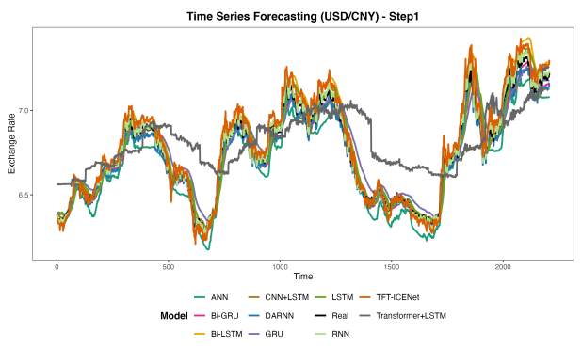  Fig. 1. (a) Prediction results of the step1 of the USD/CNY | 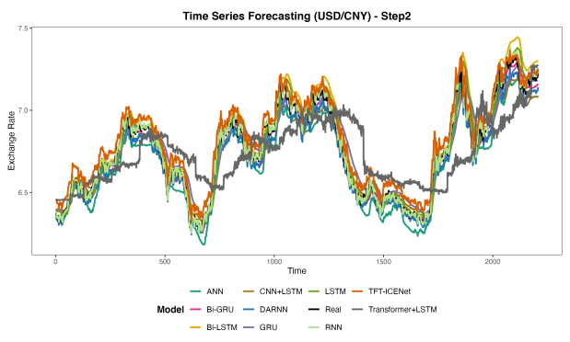  Fig. 1. (b) Prediction results of the step2 of the USD/CNY
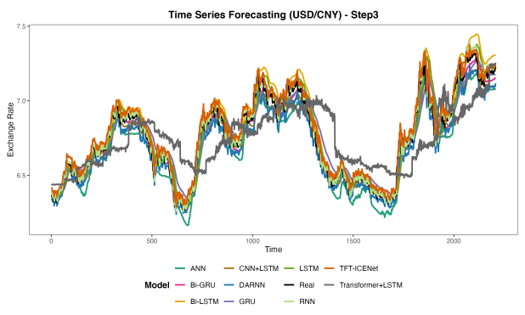  Fig. 1. (c) Prediction results of the step3 of the USD/CNY | 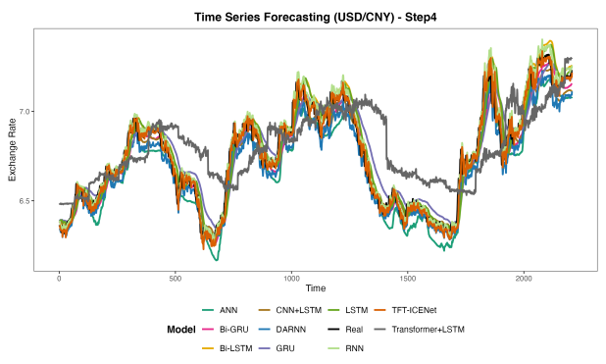  Fig. 1. (d) Prediction results of the step4 of the USD/CNY
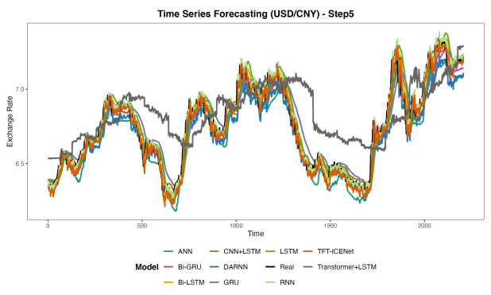  Fig. 1. (e) Prediction results of the step5 of the USD/CNY | 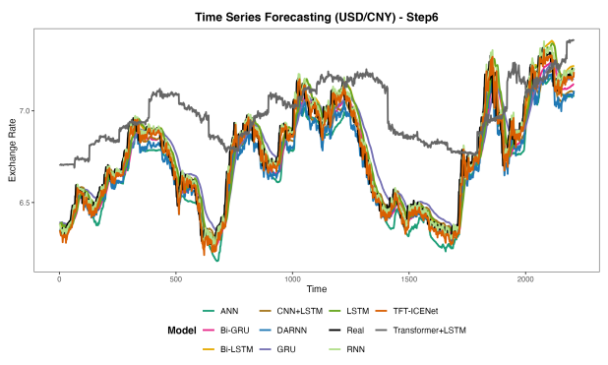  Fig. 1. (f) Prediction results of the step6 of the USD/CNY
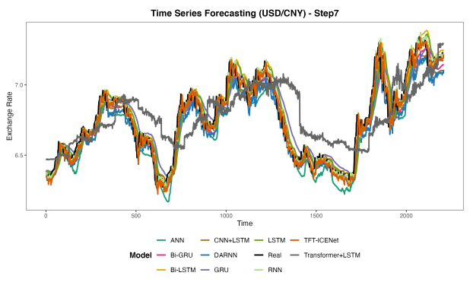  Fig. 1. (g) Prediction results of the step7 of the USD/CNY | 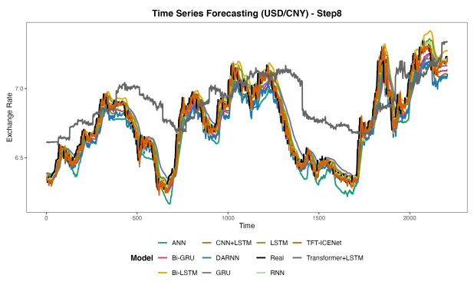  Fig. 1. (h) Prediction results of the step8 of the USD/CNY
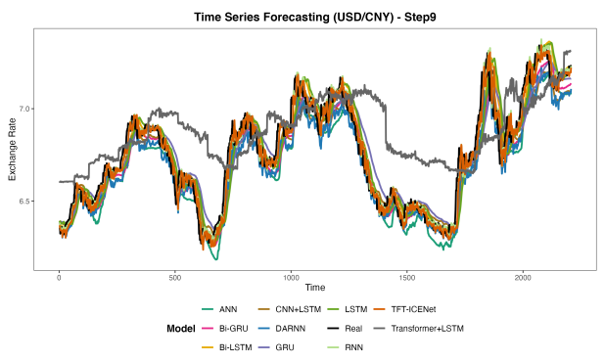  Fig. 1. (i) Prediction results of the step9 of the USD/CNY | 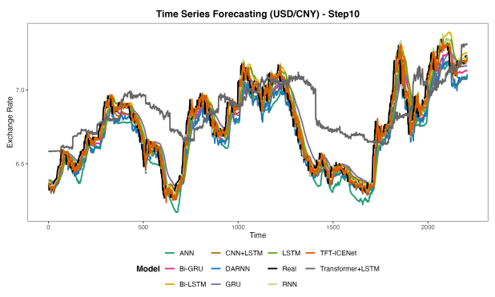  Fig. 1. (j) Prediction results of the step10 of the USD/CNY
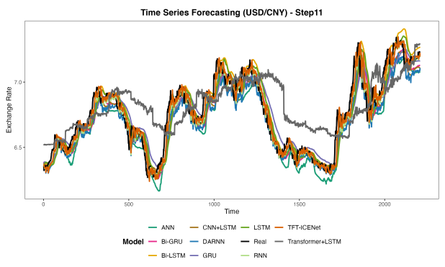  Fig. 1. (k) Prediction results of the step11 of the USD/CNY | 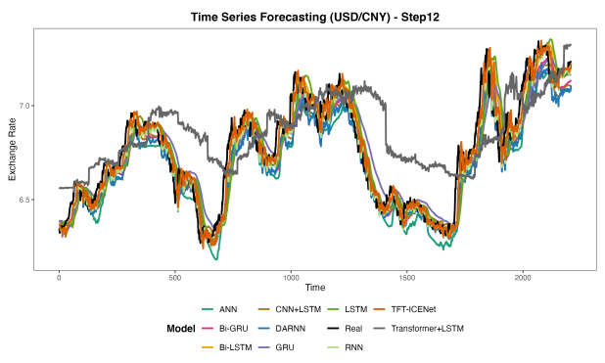  Fig. 1. (l) Prediction results of the step12 of the USD/CNY
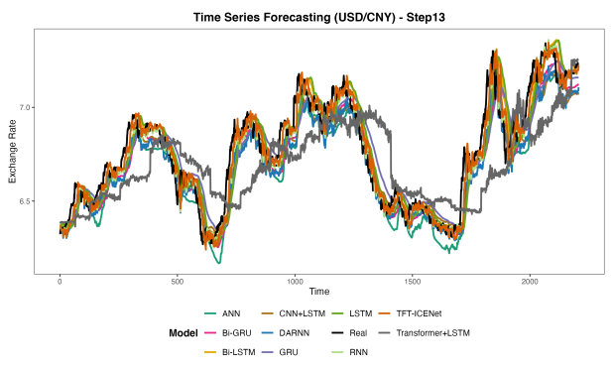  Fig. 1. (m) Prediction results of the step13 of the USD/CNY | 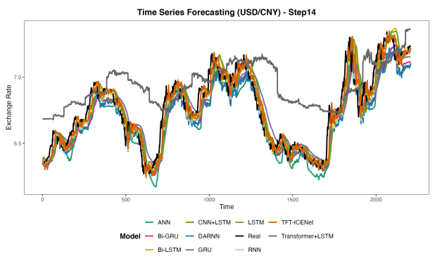  Fig. 1. (n) Prediction results of the step14 of the USD/CNY
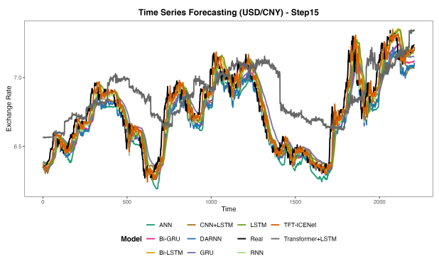  Fig. 1. (o) Prediction results of the step15 of the USD/CNY | 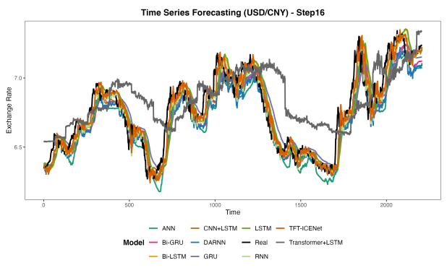  Fig. 1. (p) Prediction results of the step16 of the USD/CNY
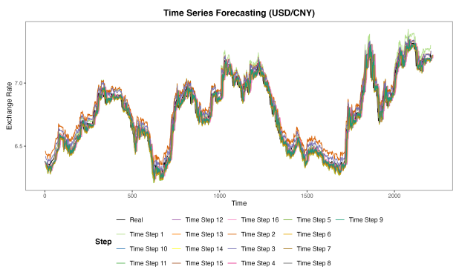
Fig. 1. (q) Prediction results of the 16 steps of the USD/CNY
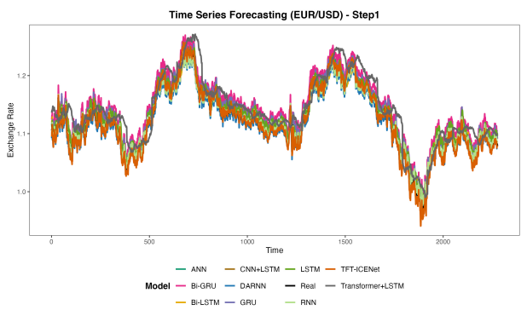  Fig. 2. (a) Prediction results of the step1 of the EUR/USD | 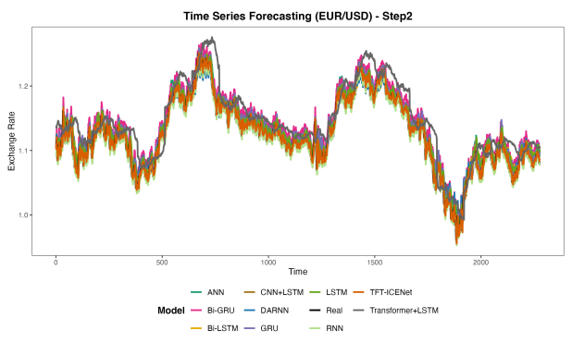  Fig. 2. (b) Prediction results of the step2 of the EUR/USD
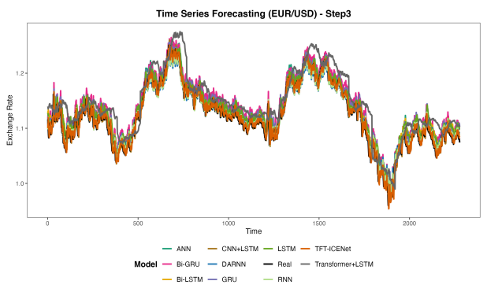  Fig. 2. (c) Prediction results of the step3 of the EUR/USD | 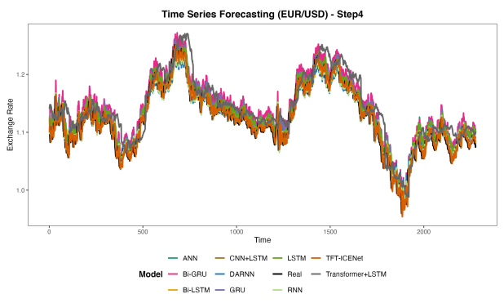  Fig. 2. (d) Prediction results of the step4 of the EUR/USD
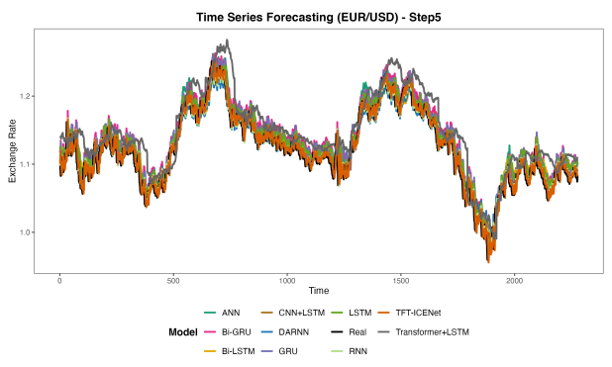  Fig. 2. (e) Prediction results of the step5 of the EUR/USD | 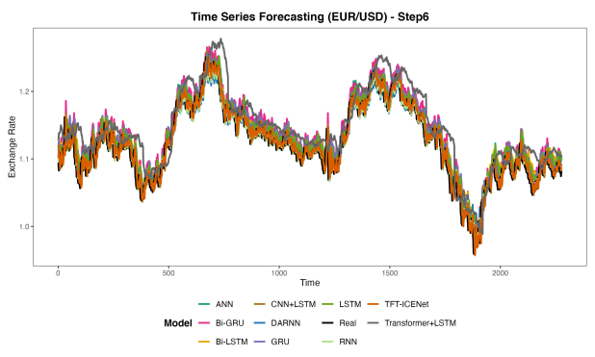  Fig. 2. (f) Prediction results of the step6 of the EUR/USD
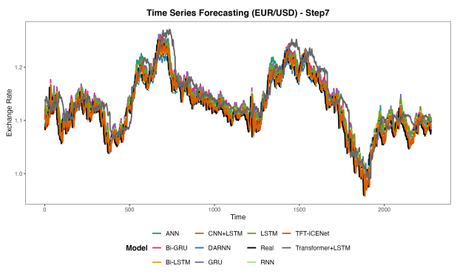  Fig. 2. (g) Prediction results of the step7 of the EUR/USD | 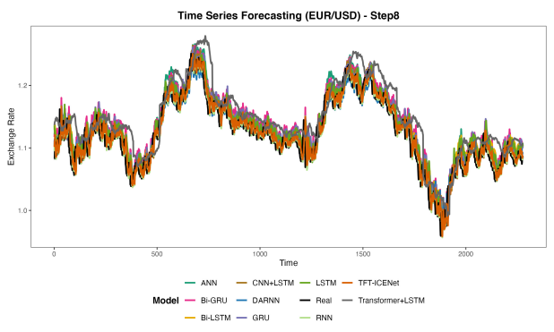  Fig. 2. (h) Prediction results of the step8 of the EUR/USD
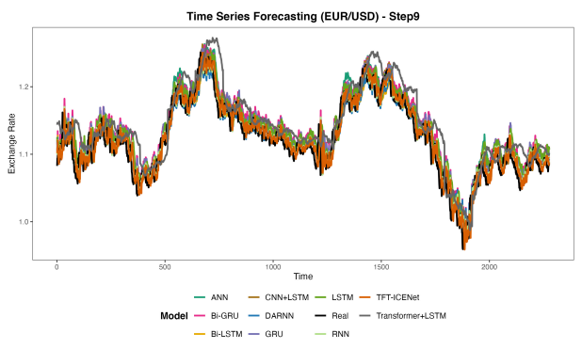  Fig. 2. (i) Prediction results of the step9 of the EUR/USD | 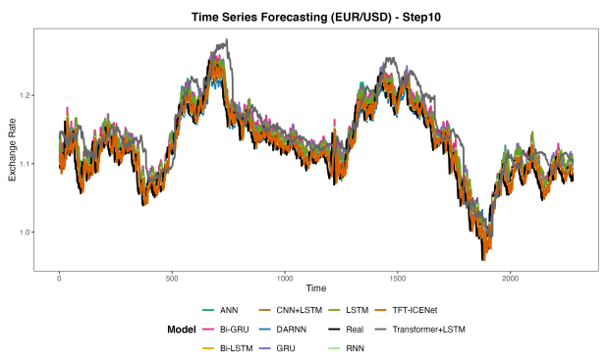  Fig. 2. (j) Prediction results of the step10 of the EUR/USD
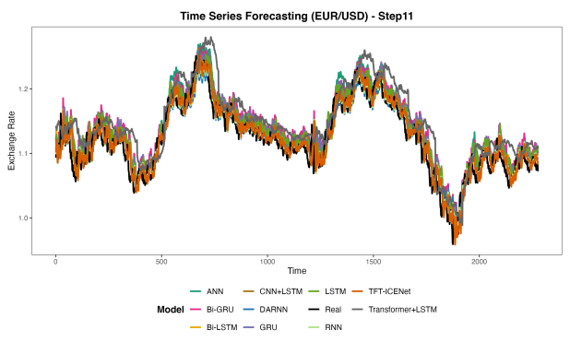  Fig. 2. (k) Prediction results of the step11 of the EUR/USD | 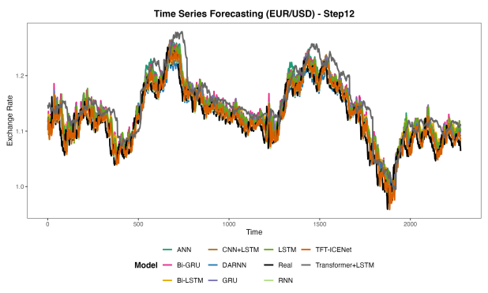  Fig. 2. (l) Prediction results of the step12 of the EUR/USD
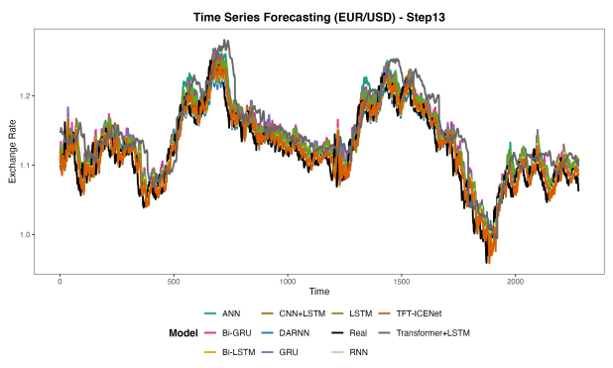  Fig. 2. (m) Prediction results of the step13 of the EUR/USD | 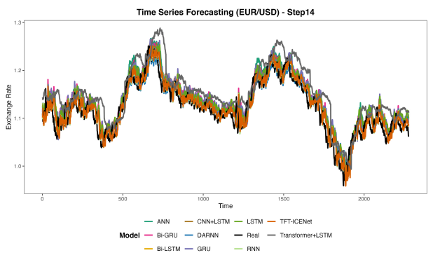  Fig. 2. (n) Prediction results of the step14 of the EUR/USD
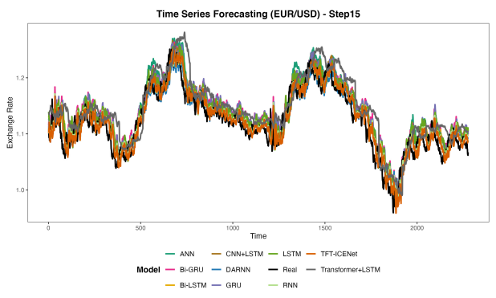  Fig. 2. (o) Prediction results of the step15 of the EUR/USD | 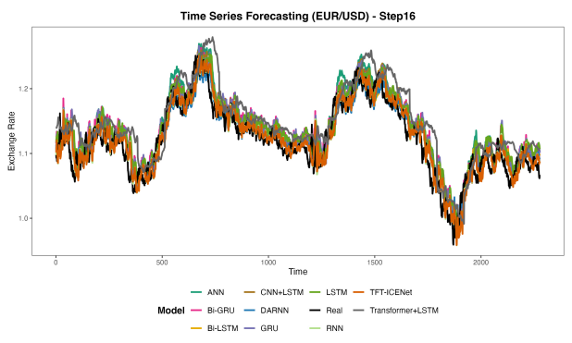  Fig. 2. (p) Prediction results of the step16 of the EUR/USD
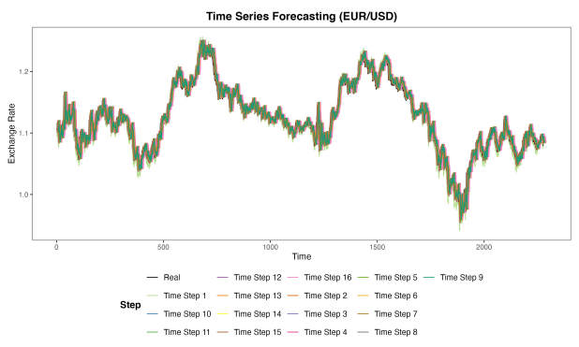
Fig. 2. (q) Prediction results of the 16 steps of the EUR/USD
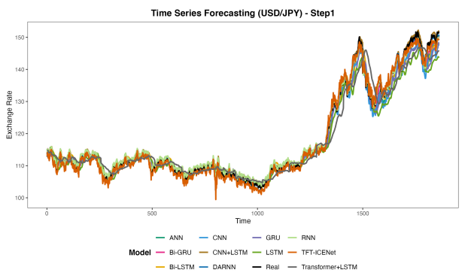  Fig. 3. (a) Prediction results of the step1 of the USD/JPY | 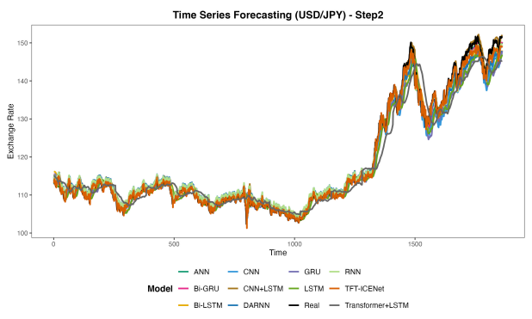  Fig. 3. (b) Prediction results of the step2 of the USD/JPY
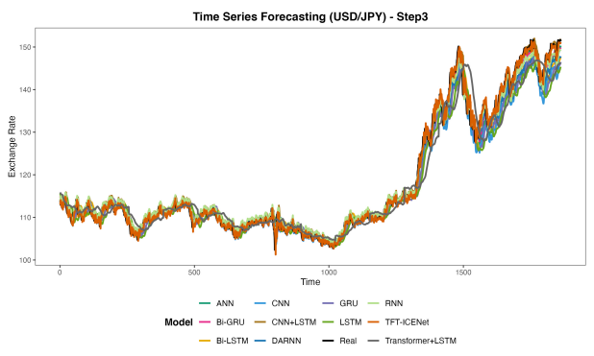  Fig. 3. (c) Prediction results of the step3 of the USD/JPY | 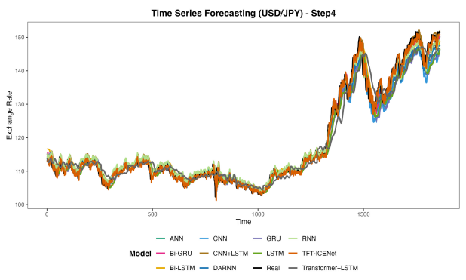  Fig. 3. (d) Prediction results of the step4 of the USD/JPY
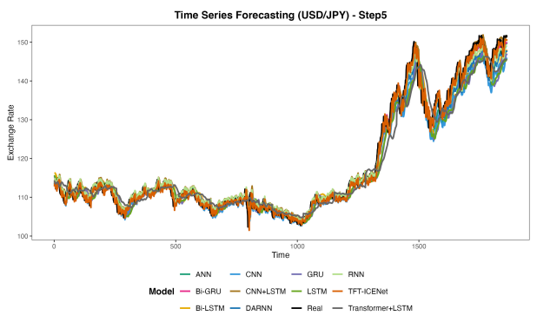  Fig. 3. (e) Prediction results of the step5 of the USD/JPY | 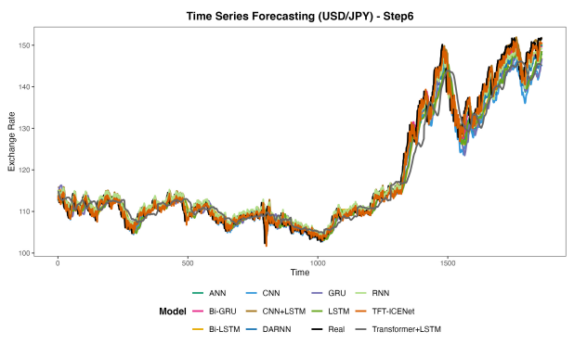  Fig. 3. (f) Prediction results of the step6 of the USD/JPY
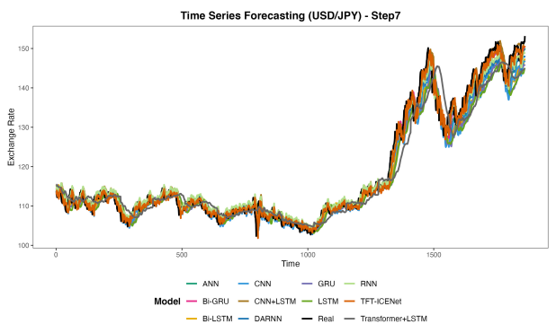  Fig. 3. (g) Prediction results of the step7 of the USD/JPY | 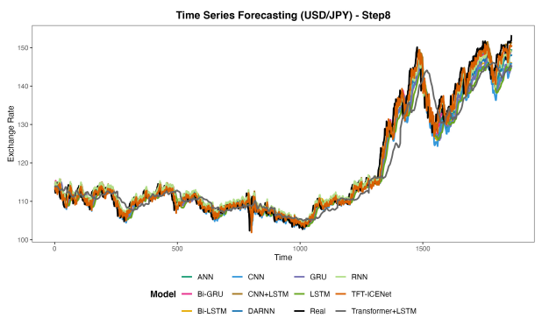  Fig. 3. (h) Prediction results of the step8 of the USD/JPY
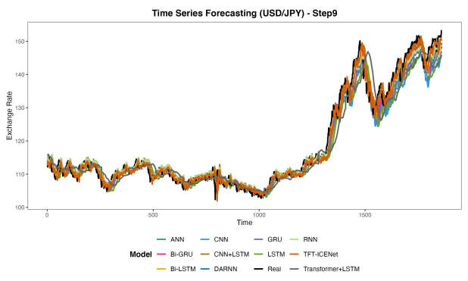  Fig. 3. (i) Prediction results of the step9 of the USD/JPY | 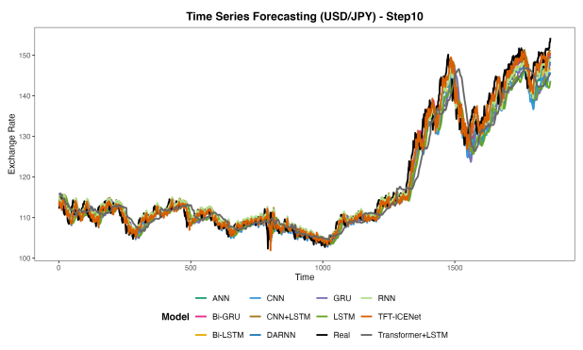  Fig. 3. (j) Prediction results of the step10 of the USD/JPY
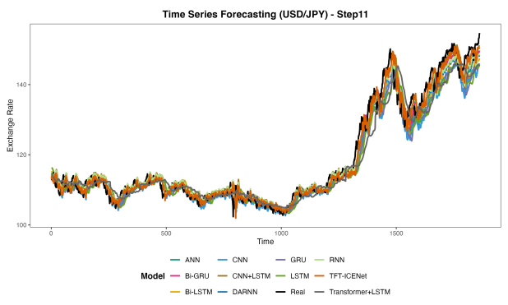  Fig. 3. (k) Prediction results of the step11 of the USD/JPY | 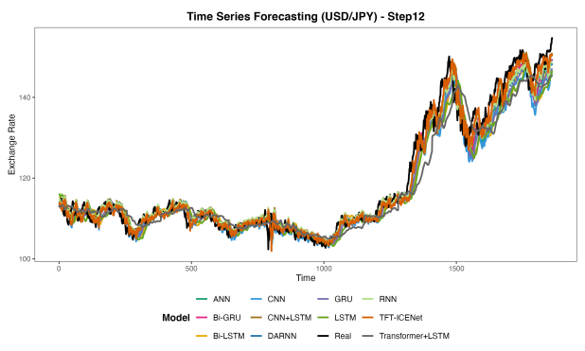  Fig. 3. (l) Prediction results of the step12 of the USD/JPY
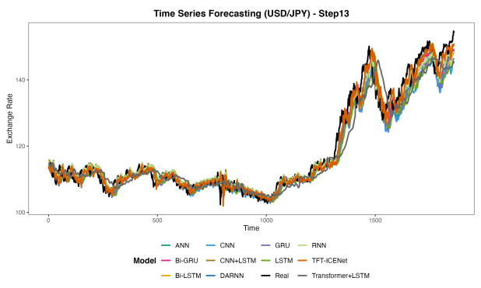  Fig. 3. (m) Prediction results of the step13 of the USD/JPY | 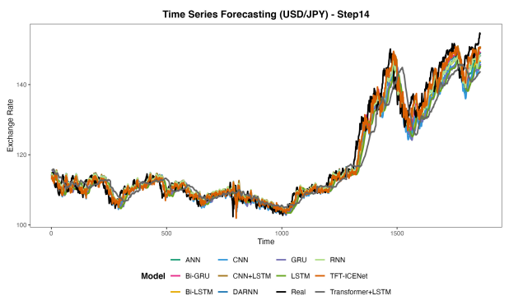  Fig. 3. (n) Prediction results of the step14 of the USD/JPY
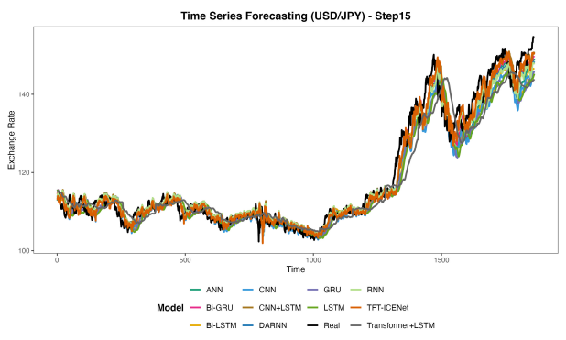  Fig. 3. (o) Prediction results of the step15 of the USD/JPY | 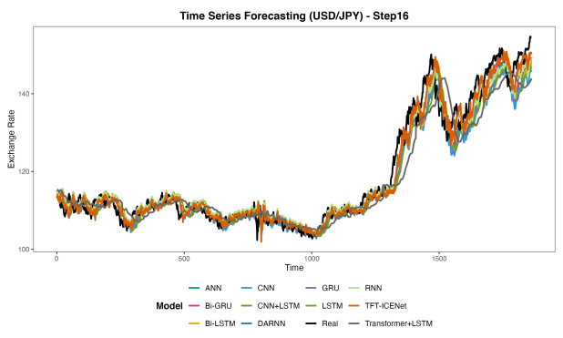  Fig. 3. (p) Prediction results of the step16 of the USD/JPY
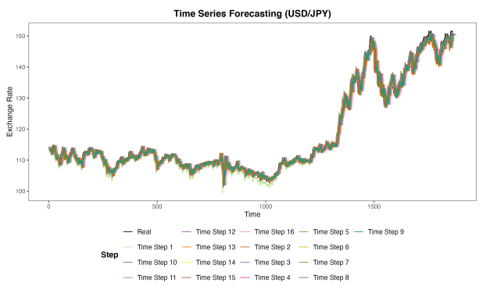
Fig. 3. (q) Prediction results of the 16 steps of the USD/JPY
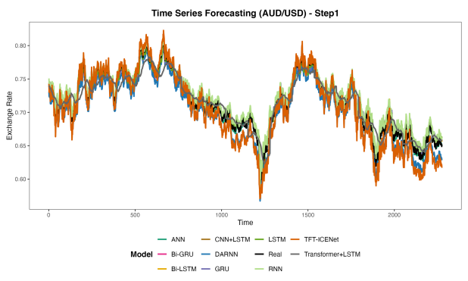  Fig. 4. (a) Prediction results of the step1 of the AUD/USD | 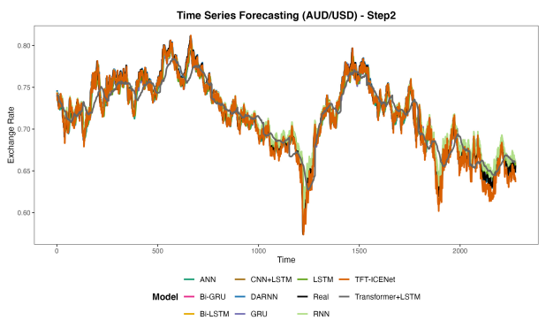  Fig. 4. (b) Prediction results of the step2 of the AUD/USD
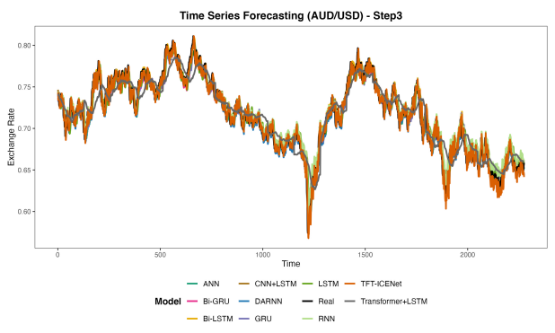  Fig. 4. (c) Prediction results of the step3 of the AUD/USD | 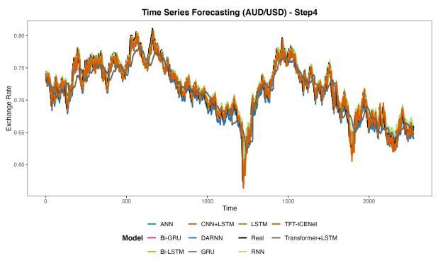  Fig. 4. (d) Prediction results of the step4 of the AUD/USD
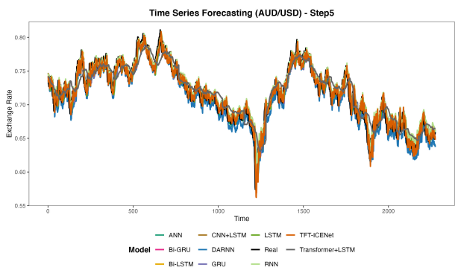  Fig. 4. (e) Prediction results of the step5 of the AUD/USD | 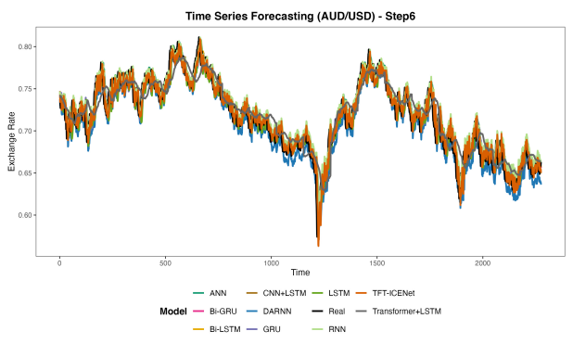  Fig. 4. (f) Prediction results of the step6 of the AUD/USD
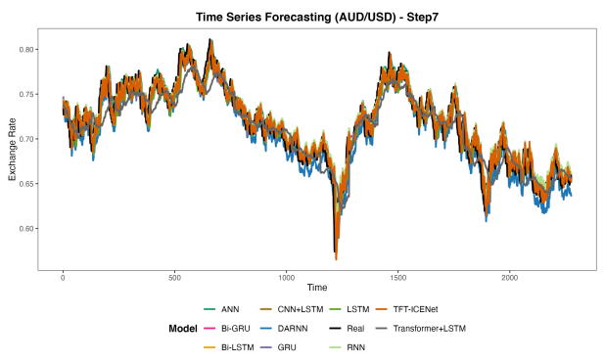  Fig. 4. (g) Prediction results of the step7 of the AUD/USD | 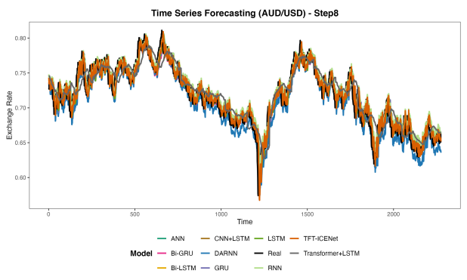  Fig. 4. (h) Prediction results of the step8 of the AUD/USD
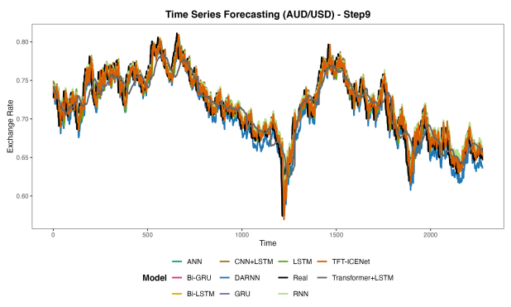  Fig. 4. (i) Prediction results of the step9 of the AUD/USD | 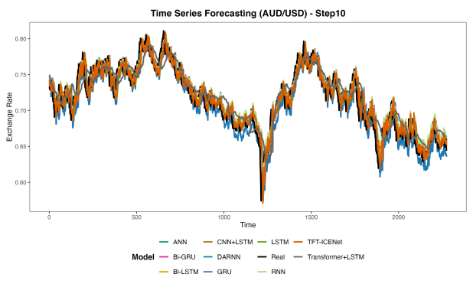  Fig. 4. (j) Prediction results of the step10 of the AUD/USD
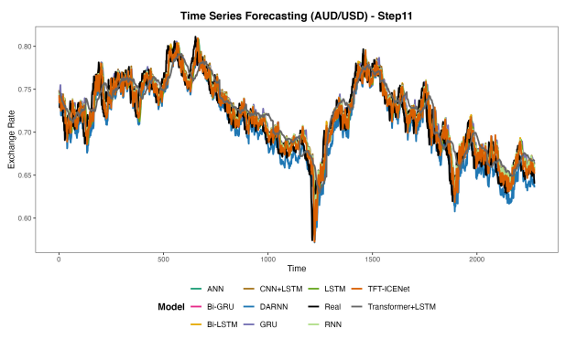  Fig. 4. (k) Prediction results of the step11 of the AUD/USD | 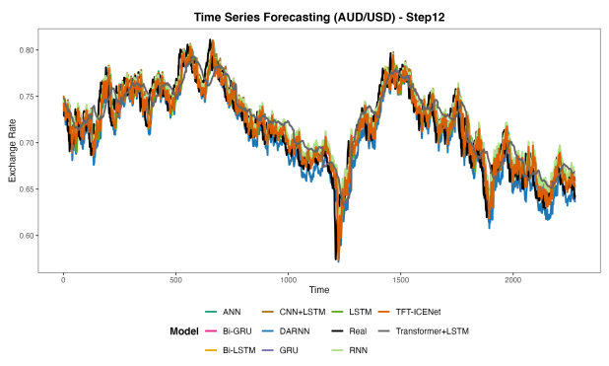  Fig. 4. (l) Prediction results of the step12 of the AUD/USD
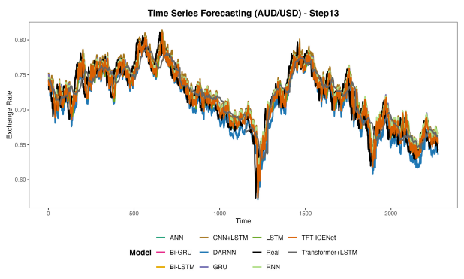  Fig. 4. (m) Prediction results of the step13 of the AUD/USD | 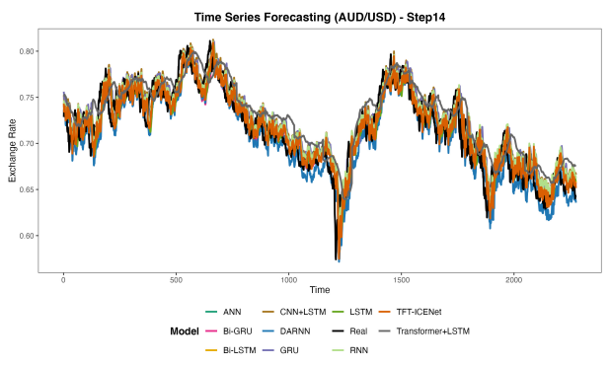  Fig. 4. (n) Prediction results of the step14 of the AUD/USD
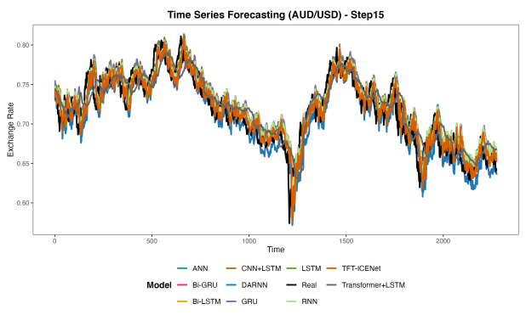  Fig. 4. (o) Prediction results of the step15 of the AUD/USD | 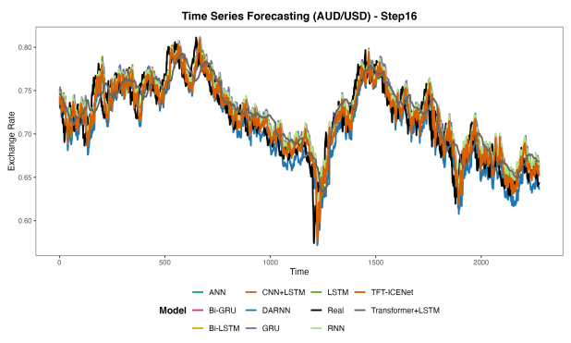  Fig. 4. (p) Prediction results of the step16 of the AUD/USD
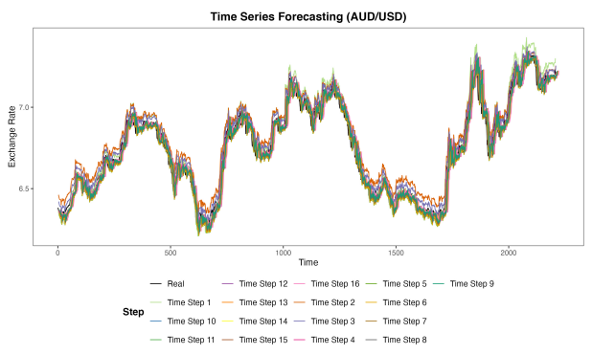
Fig. 4. (q) Prediction results of the 16 steps of the AUD/USD

3. Model Accuracy Comparison
Comparative accuracy plots for all metrics and currency pairs are provided in Figure 5.
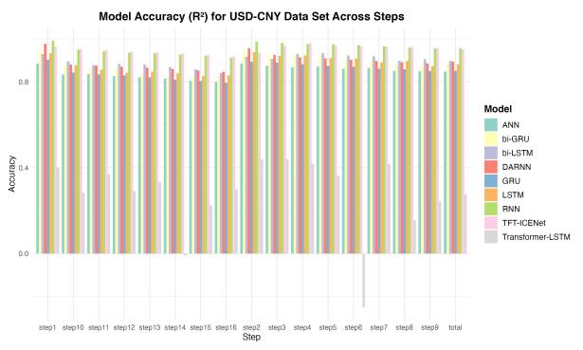  Fig. 5. (a) comparison of model accuracy (R²) for USD/CNY | 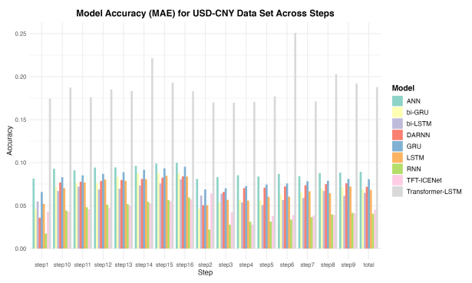  Fig. 5. (b) comparison of model accuracy (MAE) for USD/CNY
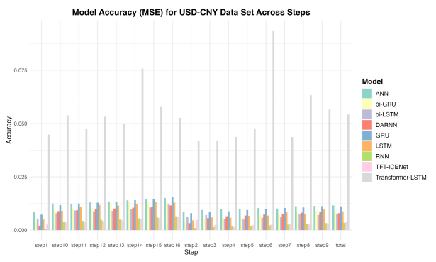  Fig. 5. (c) comparison of model accuracy (MSE) for USD/CNY | 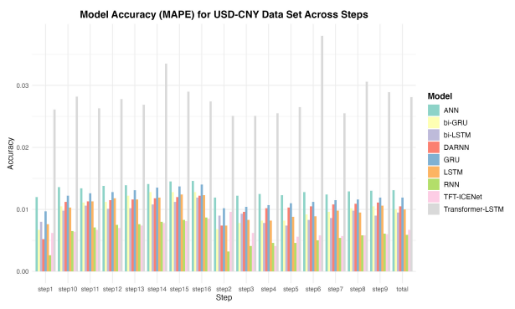  Fig. 5. (d) comparison of model accuracy (MAPE) for USD/CNY
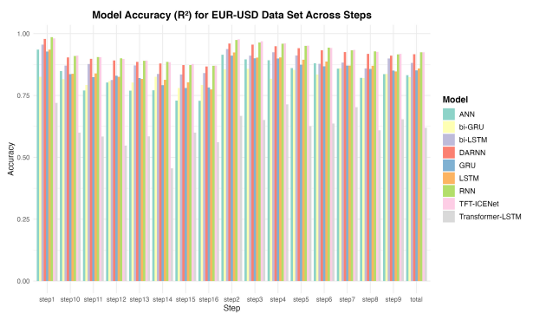  Fig. 5. (e) comparison of model accuracy (R²) for EUR/USD | 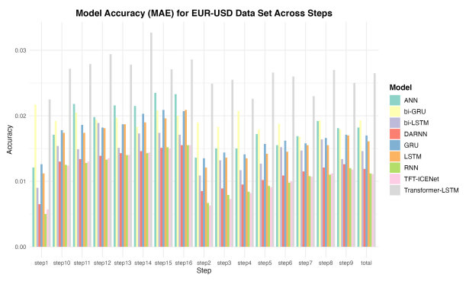  Fig. 5. (f) comparison of model accuracy (MAE) for EUR/USD
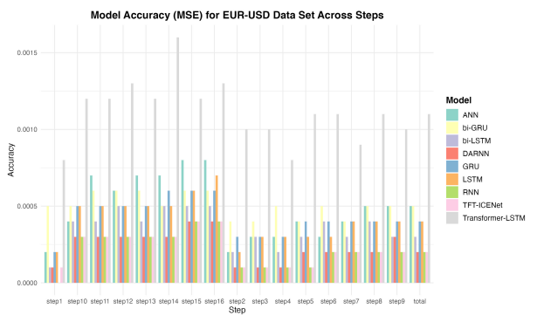  Fig. 5. (g) comparison of model accuracy (MSE) for EUR/USD | 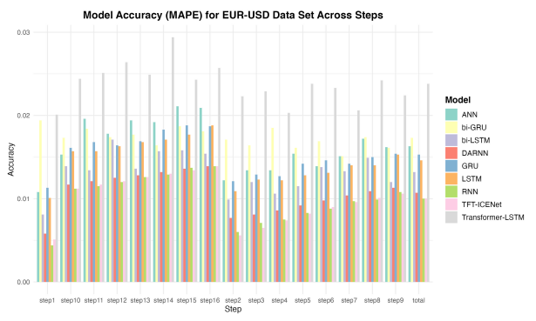  Fig. 5. (h) comparison of model accuracy (MAPE) for EUR/USD
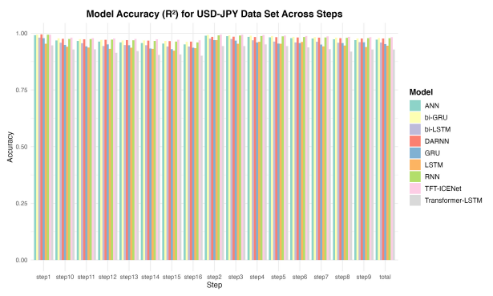  Fig. 5. (i) comparison of model accuracy (R²) for USD/JPY | 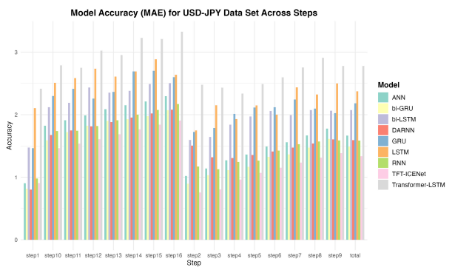  Fig. 5. (j) comparison of model accuracy (MAE) for USD/JPY
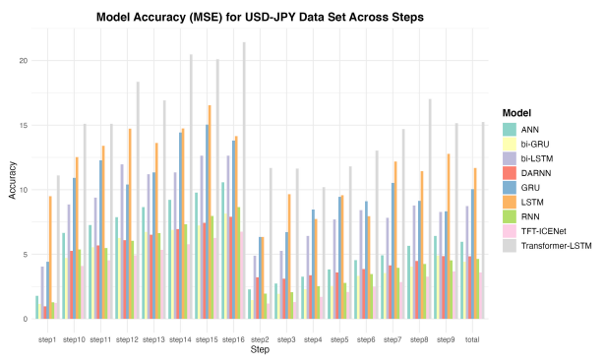  Fig. 5. (k) comparison of model accuracy (MSE) for USD/JPY | 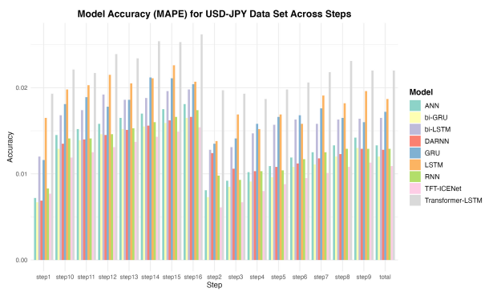  Fig. 5. (l) comparison of model accuracy (MAPE) for USD/JPY
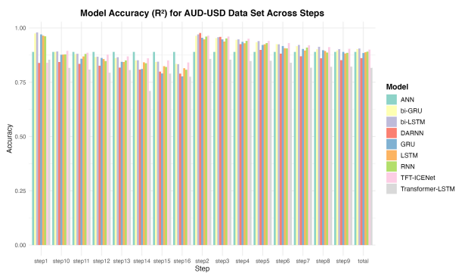  Fig. 5. (m) comparison of model accuracy (R²) for AUD/USD | 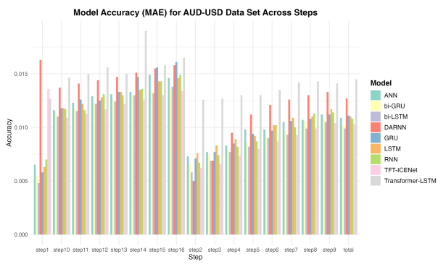  Fig. 5. (n) comparison of model accuracy (MAE) for AUD/USD
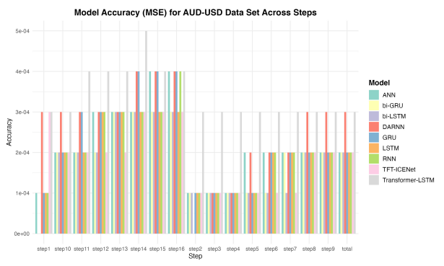  Fig. 5. (o) comparison of model accuracy (MSE) for AUD/USD | 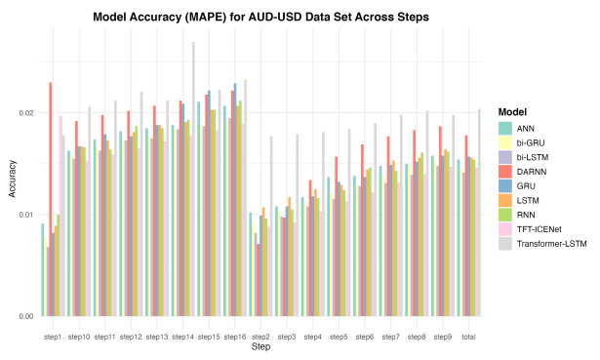  Fig. 5. (p) comparison of model accuracy (MAPE) for AUD/USD

4. Ablation Study Results
Ablation studies were conducted to evaluate the contribution of each attention mechanism in the proposed model. Four variants were compared:
w/o All Attention: All attention modules removed.
w/o Hierarchical Attention: Only hierarchical attention removed.
w/o Temporal Decoder Attention: Only temporal decoder attention removed.
w/o Input Attention: Only input attention removed.
Results are reported in Tables 5-8 for each currency pair.
Table 5 Ablation Study Results (USD/CNY Exchange Rate Forecasting).
$$R^{2}$$ | w/o All Attention | w/o Hierarchical Attention | w/o Temporal Decoder Attention | w/o Input Attention
step1 | 0.3492 | 0.8928 | 0.9847 | -29.4931
step2 | 0.9438 | 0.9812 | 0.0616 | -1.8790
step3 | 0.9504 | 0.9827 | 0.6998 | -23.4930
step4 | 0.9260 | 0.9751 | 0.8194 | -31.3591
step5 | 0.9151 | 0.9707 | 0.8110 | -29.5534
step6 | 0.9104 | 0.9665 | 0.7870 | -27.0539
step7 | 0.9068 | 0.9616 | 0.7667 | -26.2595
step8 | 0.9027 | 0.9563 | 0.7516 | -26.8062
step9 | 0.8978 | 0.9508 | 0.7401 | -27.8987
step10 | 0.8923 | 0.9452 | 0.7308 | -28.9847
step11 | 0.8863 | 0.9397 | 0.7231 | -29.8341
step12 | 0.8799 | 0.9343 | 0.7165 | -30.4277
step13 | 0.8731 | 0.9287 | 0.7101 | -30.8303
step14 | 0.8660 | 0.9226 | 0.7038 | -31.1122
step15 | 0.8588 | 0.9163 | 0.6976 | -31.3148
step16 | 0.8513 | 0.9098 | 0.6914 | -31.4661
total | 0.8631 | 0.9459 | 0.7122 | -27.3604
$$MAE$$ | w/o All Attention | w/o Hierarchical Attention | w/o Temporal Decoder Attention | w/o Input Attention
step1 | 0.2152 | 0.0838 | 0.0282 | 1.5034
step2 | 0.0536 | 0.0304 | 0.2629 | 0.4612
step3 | 0.0480 | 0.0270 | 0.1462 | 1.3516
step4 | 0.0610 | 0.0329 | 0.1093 | 1.5527
step5 | 0.0653 | 0.0353 | 0.1094 | 1.5075
step6 | 0.0662 | 0.0373 | 0.1151 | 1.4431
step7 | 0.0665 | 0.0397 | 0.1197 | 1.4213
step8 | 0.0670 | 0.0422 | 0.1228 | 1.4347
step9 | 0.0681 | 0.0446 | 0.1249 | 1.4622
step10 | 0.0694 | 0.0470 | 0.1265 | 1.4892
step11 | 0.0710 | 0.0494 | 0.1276 | 1.5101
step12 | 0.0728 | 0.0516 | 0.1284 | 1.5244
step13 | 0.0746 | 0.0538 | 0.1292 | 1.5340
step14 | 0.0764 | 0.0562 | 0.1299 | 1.5406
step15 | 0.0783 | 0.0583 | 0.1306 | 1.5453
step16 | 0.0802 | 0.0606 | 0.1314 | 1.5488
total | 0.0771 | 0.0469 | 0.1276 | 1.4269
$$MSE$$ | w/o All Attention | w/o Hierarchical Attention | w/o Temporal Decoder Attention | w/o Input Attention
step1 | 0.0487 | 0.0080 | 0.0011 | 2.2797
step2 | 0.0042 | 0.0014 | 0.0702 | 0.2153
step3 | 0.0037 | 0.0013 | 0.0225 | 1.8327
step4 | 0.0055 | 0.0019 | 0.0135 | 2.4222
step5 | 0.0064 | 0.0022 | 0.0142 | 2.2878
step6 | 0.0067 | 0.0025 | 0.0160 | 2.1014
step7 | 0.0070 | 0.0029 | 0.0175 | 2.0426
step8 | 0.0073 | 0.0033 | 0.0186 | 2.0843
step9 | 0.0077 | 0.0037 | 0.0195 | 2.1670
step10 | 0.0081 | 0.0041 | 0.0202 | 2.2492
step11 | 0.0085 | 0.0045 | 0.0208 | 2.3137
step12 | 0.0090 | 0.0049 | 0.0213 | 2.3590
step13 | 0.0095 | 0.0054 | 0.0218 | 2.3900
step14 | 0.0101 | 0.0058 | 0.0222 | 2.4116
step15 | 0.0106 | 0.0063 | 0.0227 | 2.4275
step16 | 0.0112 | 0.0068 | 0.0232 | 2.4396
total | 0.0103 | 0.0041 | 0.0216 | 2.1265
$$MAPE$$ | w/o All Attention | w/o Hierarchical Attention | w/o Temporal Decoder Attention | w/o Input Attention
step1 | 0.0320 | 0.0126 | 0.0042 | 0.2220
step2 | 0.0079 | 0.0046 | 0.0391 | 0.0685
step3 | 0.0070 | 0.0040 | 0.0217 | 0.2000
step4 | 0.0089 | 0.0048 | 0.0161 | 0.2296
step5 | 0.0096 | 0.0052 | 0.0161 | 0.2228
step6 | 0.0097 | 0.0055 | 0.0169 | 0.2132
step7 | 0.0097 | 0.0058 | 0.0176 | 0.2099
step8 | 0.0098 | 0.0062 | 0.0180 | 0.2118
step9 | 0.0100 | 0.0065 | 0.0184 | 0.2158
step10 | 0.0102 | 0.0069 | 0.0186 | 0.2198
step11 | 0.0104 | 0.0072 | 0.0188 | 0.2228
step12 | 0.0107 | 0.0076 | 0.0189 | 0.2249
step13 | 0.0109 | 0.0079 | 0.0190 | 0.2263
step14 | 0.0112 | 0.0082 | 0.0191 | 0.2273
step15 | 0.0115 | 0.0086 | 0.0192 | 0.2280
step16 | 0.0118 | 0.0089 | 0.0193 | 0.2285
total | 0.0113 | 0.0069 | 0.0188 | 0.2107

Table 6 Ablation Study Results (EUR/USD Exchange Rate Forecasting).
$$R^{2}$$ | w/o All Attention | w/o Hierarchical Attention | w/o Temporal Decoder Attention | w/o Input Attention
step1 | 0.9882 | 0.9897 | 0.9687 | 0.9739
step2 | 0.9789 | 0.9798 | 0.9702 | 0.9722
step3 | 0.9693 | 0.9704 | 0.9602 | 0.9595
step4 | 0.9603 | 0.9614 | 0.9512 | 0.9491
step5 | 0.9515 | 0.9522 | 0.9434 | 0.9400
step6 | 0.9428 | 0.9434 | 0.9356 | 0.9312
step7 | 0.9352 | 0.9357 | 0.9286 | 0.9233
step8 | 0.9280 | 0.9287 | 0.9219 | 0.9159
step9 | 0.9206 | 0.9213 | 0.9145 | 0.9080
step10 | 0.9133 | 0.9140 | 0.9069 | 0.9001
step11 | 0.9064 | 0.9073 | 0.8999 | 0.8929
step12 | 0.8996 | 0.9007 | 0.8930 | 0.8859
step13 | 0.8929 | 0.8941 | 0.8862 | 0.8789
step14 | 0.8861 | 0.8876 | 0.8795 | 0.8720
step15 | 0.8788 | 0.8803 | 0.8719 | 0.8643
step16 | 0.8719 | 0.8738 | 0.8651 | 0.8572
total | 0.9265 | 0.9275 | 0.9185 | 0.9140
$$MAE$$ | w/o All Attention | w/o Hierarchical Attention | w/o Temporal Decoder Attention | w/o Input Attention
step1 | 0.0044 | 0.0041 | 0.0074 | 0.0069
step2 | 0.0059 | 0.0058 | 0.0072 | 0.0069
step3 | 0.0072 | 0.0071 | 0.0082 | 0.0083
step4 | 0.0082 | 0.0081 | 0.0092 | 0.0095
step5 | 0.0091 | 0.0091 | 0.0099 | 0.0102
step6 | 0.0099 | 0.0098 | 0.0105 | 0.0109
step7 | 0.0105 | 0.0105 | 0.0111 | 0.0115
step8 | 0.0111 | 0.0110 | 0.0116 | 0.0121
step9 | 0.0117 | 0.0116 | 0.0121 | 0.0126
step10 | 0.0122 | 0.0122 | 0.0127 | 0.0132
step11 | 0.0128 | 0.0127 | 0.0133 | 0.0138
step12 | 0.0133 | 0.0133 | 0.0138 | 0.0144
step13 | 0.0138 | 0.0137 | 0.0143 | 0.0148
step14 | 0.0143 | 0.0142 | 0.0148 | 0.0153
step15 | 0.0148 | 0.0147 | 0.0153 | 0.0158
step16 | 0.0153 | 0.0152 | 0.0158 | 0.0163
total | 0.0109 | 0.0108 | 0.0117 | 0.0120
$$MSE$$ | w/o All Attention | w/o Hierarchical Attention | w/o Temporal Decoder Attention | w/o Input Attention
step1 | 0.0000 | 0.0000 | 0.0001 | 0.0001
step2 | 0.0001 | 0.0001 | 0.0001 | 0.0001
step3 | 0.0001 | 0.0001 | 0.0001 | 0.0001
step4 | 0.0001 | 0.0001 | 0.0001 | 0.0001
step5 | 0.0001 | 0.0001 | 0.0002 | 0.0002
step6 | 0.0002 | 0.0002 | 0.0002 | 0.0002
step7 | 0.0002 | 0.0002 | 0.0002 | 0.0002
step8 | 0.0002 | 0.0002 | 0.0002 | 0.0002
step9 | 0.0002 | 0.0002 | 0.0002 | 0.0003
step10 | 0.0003 | 0.0002 | 0.0003 | 0.0003
step11 | 0.0003 | 0.0003 | 0.0003 | 0.0003
step12 | 0.0003 | 0.0003 | 0.0003 | 0.0003
step13 | 0.0003 | 0.0003 | 0.0003 | 0.0004
step14 | 0.0003 | 0.0003 | 0.0003 | 0.0004
step15 | 0.0004 | 0.0003 | 0.0004 | 0.0004
step16 | 0.0004 | 0.0004 | 0.0004 | 0.0004
total | 0.0002 | 0.0002 | 0.0002 | 0.0002
$$MAPE$$ | w/o All Attention | w/o Hierarchical Attention | w/o Temporal Decoder Attention | w/o Input Attention
step1 | 0.0040 | 0.0037 | 0.0068 | 0.0062
step2 | 0.0053 | 0.0052 | 0.0065 | 0.0061
step3 | 0.0065 | 0.0064 | 0.0074 | 0.0075
step4 | 0.0074 | 0.0073 | 0.0082 | 0.0085
step5 | 0.0082 | 0.0081 | 0.0089 | 0.0092
step6 | 0.0089 | 0.0088 | 0.0094 | 0.0097
step7 | 0.0094 | 0.0094 | 0.0099 | 0.0103
step8 | 0.0099 | 0.0099 | 0.0104 | 0.0108
step9 | 0.0105 | 0.0104 | 0.0109 | 0.0113
step10 | 0.0110 | 0.0109 | 0.0114 | 0.0119
step11 | 0.0115 | 0.0114 | 0.0119 | 0.0124
step12 | 0.0120 | 0.0119 | 0.0124 | 0.0129
step13 | 0.0124 | 0.0123 | 0.0128 | 0.0133
step14 | 0.0128 | 0.0127 | 0.0133 | 0.0138
step15 | 0.0133 | 0.0132 | 0.0138 | 0.0142
step16 | 0.0138 | 0.0137 | 0.0142 | 0.0146
total | 0.0098 | 0.0097 | 0.0105 | 0.0108

Table 7 Ablation Study Results (AUD/USD Exchange Rate Forecasting).
$$R^{2}$$ | w/o All Attention | w/o Hierarchical Attention | w/o Temporal Decoder Attention | w/o Input Attention
step1 | 0.9460 | 0.9661 | 0.8652 | 0.8989
step2 | 0.9074 | 0.9244 | 0.9154 | 0.8862
step3 | 0.8975 | 0.9179 | 0.8419 | 0.8639
step4 | 0.8868 | 0.9047 | 0.8638 | 0.8316
step5 | 0.8748 | 0.8911 | 0.8853 | 0.8098
step6 | 0.8635 | 0.8788 | 0.8956 | 0.7966
step7 | 0.8531 | 0.8680 | 0.8982 | 0.7880
step8 | 0.8431 | 0.8580 | 0.8963 | 0.7806
step9 | 0.8336 | 0.8490 | 0.8924 | 0.7730
step10 | 0.8242 | 0.8396 | 0.8865 | 0.7648
step11 | 0.8147 | 0.8303 | 0.8797 | 0.7560
step12 | 0.8054 | 0.8212 | 0.8723 | 0.7470
step13 | 0.7961 | 0.8119 | 0.8644 | 0.7378
step14 | 0.7868 | 0.8023 | 0.8559 | 0.7287
step15 | 0.7777 | 0.7922 | 0.8472 | 0.7195
step16 | 0.7686 | 0.7824 | 0.8386 | 0.7104
total | 0.8425 | 0.8586 | 0.8749 | 0.7871
$$MAE$$ | w/o All Attention | w/o Hierarchical Attention | w/o Temporal Decoder Attention | w/o Input Attention
step1 | 0.0079 | 0.0068 | 0.0146 | 0.0107
step2 | 0.0107 | 0.0103 | 0.0109 | 0.0115
step3 | 0.0111 | 0.0103 | 0.0153 | 0.0127
step4 | 0.0116 | 0.0109 | 0.0136 | 0.0143
step5 | 0.0121 | 0.0115 | 0.0120 | 0.0152
step6 | 0.0126 | 0.0120 | 0.0112 | 0.0156
step7 | 0.0130 | 0.0125 | 0.0109 | 0.0159
step8 | 0.0135 | 0.0129 | 0.0110 | 0.0161
step9 | 0.0139 | 0.0133 | 0.0112 | 0.0164
step10 | 0.0143 | 0.0136 | 0.0114 | 0.0167
step11 | 0.0147 | 0.0140 | 0.0117 | 0.0170
step12 | 0.0151 | 0.0144 | 0.0121 | 0.0173
step13 | 0.0155 | 0.0148 | 0.0124 | 0.0177
step14 | 0.0159 | 0.0152 | 0.0128 | 0.0180
step15 | 0.0162 | 0.0156 | 0.0132 | 0.0183
step16 | 0.0166 | 0.0160 | 0.0135 | 0.0186
total | 0.0134 | 0.0128 | 0.0135 | 0.0158
$$MSE$$ | w/o All Attention | w/o Hierarchical Attention | w/o Temporal Decoder Attention | w/o Input Attention
step1 | 0.0001 | 0.0001 | 0.0002 | 0.0002
step2 | 0.0002 | 0.0001 | 0.0002 | 0.0002
step3 | 0.0002 | 0.0002 | 0.0003 | 0.0003
step4 | 0.0002 | 0.0002 | 0.0003 | 0.0003
step5 | 0.0002 | 0.0002 | 0.0002 | 0.0004
step6 | 0.0003 | 0.0002 | 0.0002 | 0.0004
step7 | 0.0003 | 0.0002 | 0.0002 | 0.0004
step8 | 0.0003 | 0.0003 | 0.0002 | 0.0004
step9 | 0.0003 | 0.0003 | 0.0002 | 0.0004
step10 | 0.0003 | 0.0003 | 0.0002 | 0.0004
step11 | 0.0003 | 0.0003 | 0.0002 | 0.0005
step12 | 0.0004 | 0.0003 | 0.0002 | 0.0005
step13 | 0.0004 | 0.0004 | 0.0003 | 0.0005
step14 | 0.0004 | 0.0004 | 0.0003 | 0.0005
step15 | 0.0004 | 0.0004 | 0.0003 | 0.0005
step16 | 0.0004 | 0.0004 | 0.0003 | 0.0005
total | 0.0003 | 0.0003 | 0.0003 | 0.0004
$$MAPE$$ | w/o All Attention | w/o Hierarchical Attention | w/o Temporal Decoder Attention | w/o Input Attention
step1 | 0.0112 | 0.0095 | 0.0202 | 0.0153
step2 | 0.0151 | 0.0144 | 0.0152 | 0.0163
step3 | 0.0157 | 0.0145 | 0.0215 | 0.0179
step4 | 0.0163 | 0.0154 | 0.0192 | 0.0201
step5 | 0.0171 | 0.0163 | 0.0169 | 0.0214
step6 | 0.0177 | 0.0170 | 0.0157 | 0.0221
step7 | 0.0184 | 0.0177 | 0.0152 | 0.0225
step8 | 0.0190 | 0.0182 | 0.0153 | 0.0228
step9 | 0.0196 | 0.0188 | 0.0156 | 0.0232
step10 | 0.0202 | 0.0193 | 0.0160 | 0.0236
step11 | 0.0208 | 0.0199 | 0.0164 | 0.0241
step12 | 0.0214 | 0.0204 | 0.0169 | 0.0245
step13 | 0.0219 | 0.0210 | 0.0174 | 0.0250
step14 | 0.0225 | 0.0215 | 0.0180 | 0.0255
step15 | 0.0230 | 0.0220 | 0.0185 | 0.0260
step16 | 0.0235 | 0.0227 | 0.0190 | 0.0264
total | 0.0190 | 0.0180 | 0.0190 | 0.0223

Table 8 Ablation Study Results (USD/JPY Exchange Rate Forecasting).
$$R^{2}$$ | w/o All Attention | w/o Hierarchical Attention | w/o Temporal Decoder Attention | w/o Input Attention
step1 | 0.9867 | 0.9902 | 0.9794 | 0.9821
step2 | 0.9827 | 0.9860 | 0.9852 | 0.9886
step3 | 0.9807 | 0.9842 | 0.9825 | 0.9864
step4 | 0.9776 | 0.9811 | 0.9823 | 0.9846
step5 | 0.9751 | 0.9787 | 0.9827 | 0.9827
step6 | 0.9727 | 0.9763 | 0.9822 | 0.9801
step7 | 0.9703 | 0.9741 | 0.9811 | 0.9773
step8 | 0.9680 | 0.9717 | 0.9795 | 0.9747
step9 | 0.9656 | 0.9694 | 0.9777 | 0.9722
step10 | 0.9633 | 0.9671 | 0.9757 | 0.9697
step11 | 0.9610 | 0.9648 | 0.9738 | 0.9673
step12 | 0.9587 | 0.9626 | 0.9720 | 0.9650
step13 | 0.9563 | 0.9603 | 0.9700 | 0.9626
step14 | 0.9540 | 0.9580 | 0.9681 | 0.9603
step15 | 0.9516 | 0.9555 | 0.9659 | 0.9579
step16 | 0.9493 | 0.9531 | 0.9638 | 0.9556
total | 0.9671 | 0.9708 | 0.9764 | 0.9729
$$MAE$$ | w/o All Attention | w/o Hierarchical Attention | w/o Temporal Decoder Attention | w/o Input Attention
step1 | 1.4334 | 1.3075 | 1.8911 | 1.6338
step2 | 1.5493 | 1.4787 | 1.4507 | 1.1387
step3 | 1.6256 | 1.5483 | 1.6445 | 1.2746
step4 | 1.7318 | 1.6677 | 1.6363 | 1.3220
step5 | 1.8058 | 1.7420 | 1.5932 | 1.3697
step6 | 1.8760 | 1.8151 | 1.5869 | 1.4538
step7 | 1.9427 | 1.8740 | 1.6082 | 1.5455
step8 | 2.0107 | 1.9295 | 1.6511 | 1.6317
step9 | 2.0759 | 1.9856 | 1.7090 | 1.7154
step10 | 2.1426 | 2.0564 | 1.7732 | 1.7982
step11 | 2.2103 | 2.1230 | 1.8335 | 1.8796
step12 | 2.2764 | 2.1859 | 1.8981 | 1.9535
step13 | 2.3417 | 2.2551 | 1.9753 | 2.0224
step14 | 2.4034 | 2.3172 | 2.0434 | 2.0876
step15 | 2.4606 | 2.3826 | 2.1138 | 2.1486
step16 | 2.5137 | 2.4414 | 2.1793 | 2.2054
total | 2.0250 | 1.9444 | 1.7867 | 1.6988
$$MSE$$ | w/o All Attention | w/o Hierarchical Attention | w/o Temporal Decoder Attention | w/o Input Attention
step1 | 2.7460 | 2.0255 | 4.2504 | 3.6907
step2 | 3.5812 | 2.8924 | 3.0615 | 2.3558
step3 | 4.0007 | 3.2816 | 3.6319 | 2.8276
step4 | 4.6513 | 3.9394 | 3.6831 | 3.1950
step5 | 5.1956 | 4.4488 | 3.6029 | 3.6186
step6 | 5.7193 | 4.9600 | 3.7152 | 4.1734
step7 | 6.2323 | 5.4448 | 3.9590 | 4.7541
step8 | 6.7460 | 5.9538 | 4.3178 | 5.3269
step9 | 7.2568 | 6.4565 | 4.7125 | 5.8774
step10 | 7.7752 | 6.9751 | 5.1385 | 6.4172
step11 | 8.2954 | 7.4866 | 5.5666 | 6.9451
step12 | 8.8132 | 7.9774 | 5.9762 | 7.4627
step13 | 9.3410 | 8.4879 | 6.4091 | 7.9881
step14 | 9.8742 | 9.0132 | 6.8520 | 8.5188
step15 | 10.4139 | 9.5788 | 7.3378 | 9.0536
step16 | 10.9485 | 10.1293 | 7.8059 | 9.5799
total | 6.9744 | 6.1907 | 5.0013 | 5.7366
$$MAPE$$ | w/o All Attention | w/o Hierarchical Attention | w/o Temporal Decoder Attention | w/o Input Attention
step1 | 0.0122 | 0.0113 | 0.0166 | 0.0136
step2 | 0.0128 | 0.0123 | 0.0121 | 0.0094
step3 | 0.0134 | 0.0129 | 0.0142 | 0.0106
step4 | 0.0142 | 0.0139 | 0.0141 | 0.0108
step5 | 0.0148 | 0.0144 | 0.0136 | 0.0111
step6 | 0.0153 | 0.0150 | 0.0134 | 0.0117
step7 | 0.0158 | 0.0154 | 0.0134 | 0.0124
step8 | 0.0163 | 0.0158 | 0.0137 | 0.0131
step9 | 0.0168 | 0.0162 | 0.0141 | 0.0138
step10 | 0.0173 | 0.0168 | 0.0145 | 0.0144
step11 | 0.0179 | 0.0173 | 0.0150 | 0.0151
step12 | 0.0184 | 0.0178 | 0.0155 | 0.0156
step13 | 0.0189 | 0.0183 | 0.0161 | 0.0162
step14 | 0.0194 | 0.0188 | 0.0166 | 0.0167
step15 | 0.0198 | 0.0193 | 0.0172 | 0.0172
step16 | 0.0202 | 0.0197 | 0.0177 | 0.0176
total | 0.0165 | 0.0159 | 0.0149 | 0.0137

This technical report provides full experimental details and extended results supporting the findings and analyses presented in the main manuscript. All data and visualizations are publicly available for reference.

